|  |  |  |  |  |
| --- | --- | --- | --- | --- |
| **Reference** | | | | |
| Reference | Version : | Language: | Application date : | Date of review : |
| / | V0.1 | English | 2023/11/29 | AAAA/MM/JJ |
| State : | Sending function : | | Sending department : | |
| DRAFT | / | | CRM ALPHA | |

|  |  |  |  |  |  |
| --- | --- | --- | --- | --- | --- |
| **Modification history** | | | | | |
| Ver. | Date | Modified by | Checked by | Approved by | Revision object |
| V0.1 | 11/29/2023 | Dyhia AMOUR/  Olivier CHANTHASENG |  |  |  |
|  |  |  |  |  |  |
|  |  |  |  |  |  |
|  |  |  |  |  |  |

|  |  |
| --- | --- |
| **Object** | |
| Object: | Customizing guide - Brevo |
| Attachment process: | / |
| Recipient: | TEAM |

|  |  |  |  |
| --- | --- | --- | --- |
| **Signatories** | | | |
|  | Written by | Checked by | Approved by |
| Name | Dyhia AMOUR/  Olivier CHANTHESENG |  |  |
| Function | CRM Consultant |  |  |
| Date | 2023/11/29 | AAAA/MM/JJ | AAAA/MM/JJ |
| Sign |  |  |  |

|  |  |  |  |
| --- | --- | --- | --- |
| Accessibility | | | |
| ~~Public~~ | Internal | ~~Confidential~~ | ~~Restricted~~ |

Table of content

1. Login to Brevo 3

2. Create a contact 5

3. Create a list 7

4. Create a campaign 9

5. Newsletter 13

6. Create an email template 20

7. Mailing automation 24

7.1. Welcome email 24

7.2 Inscription to the Newsletter 30

# Login to Brevo

* Login to the website by using this URL: [Brevo](https://app.brevo.com/)
* Use the credentials as shown in the picture below:
* Click on “Login”

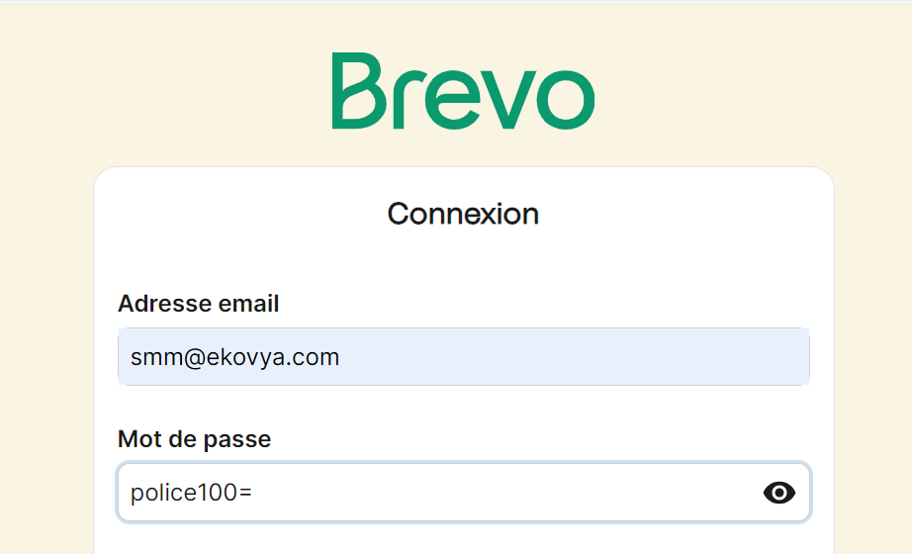

* Get the home page :

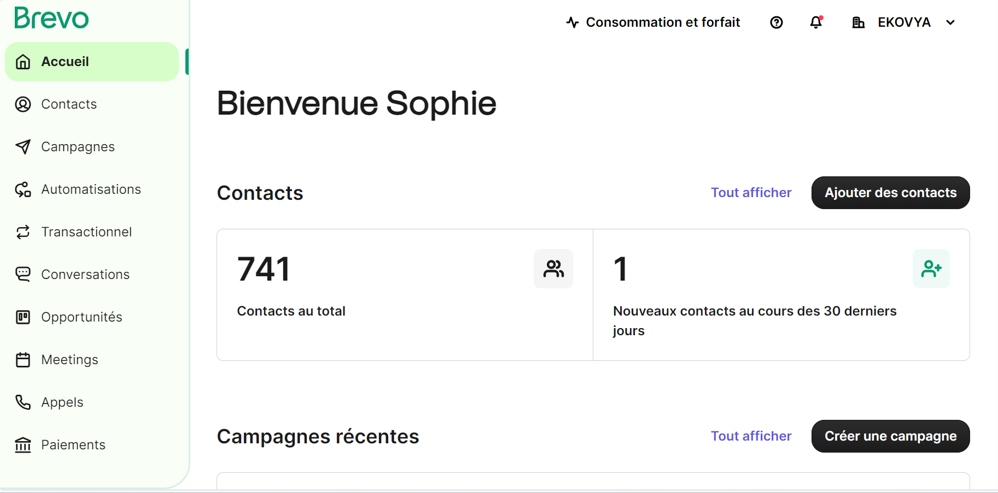

# Create a contact

* From the home page: select “Contacts”

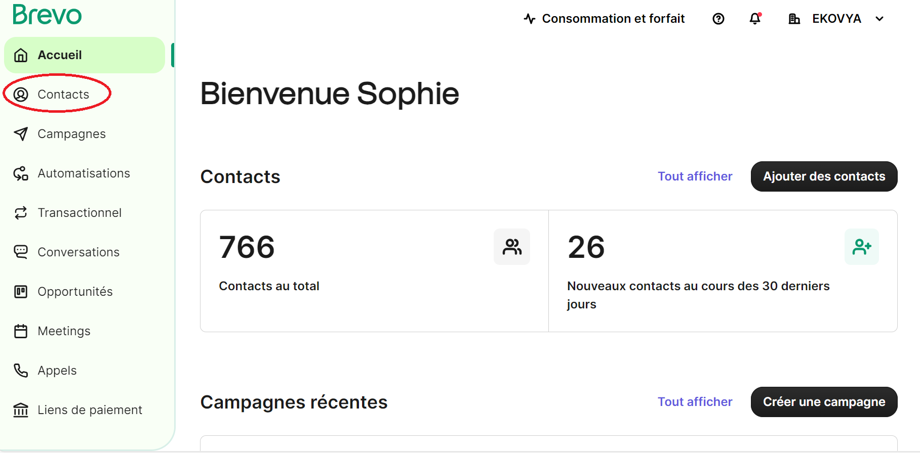

* Click on “Add a contact”

# 

* On the pop-up page: fill on necessary information

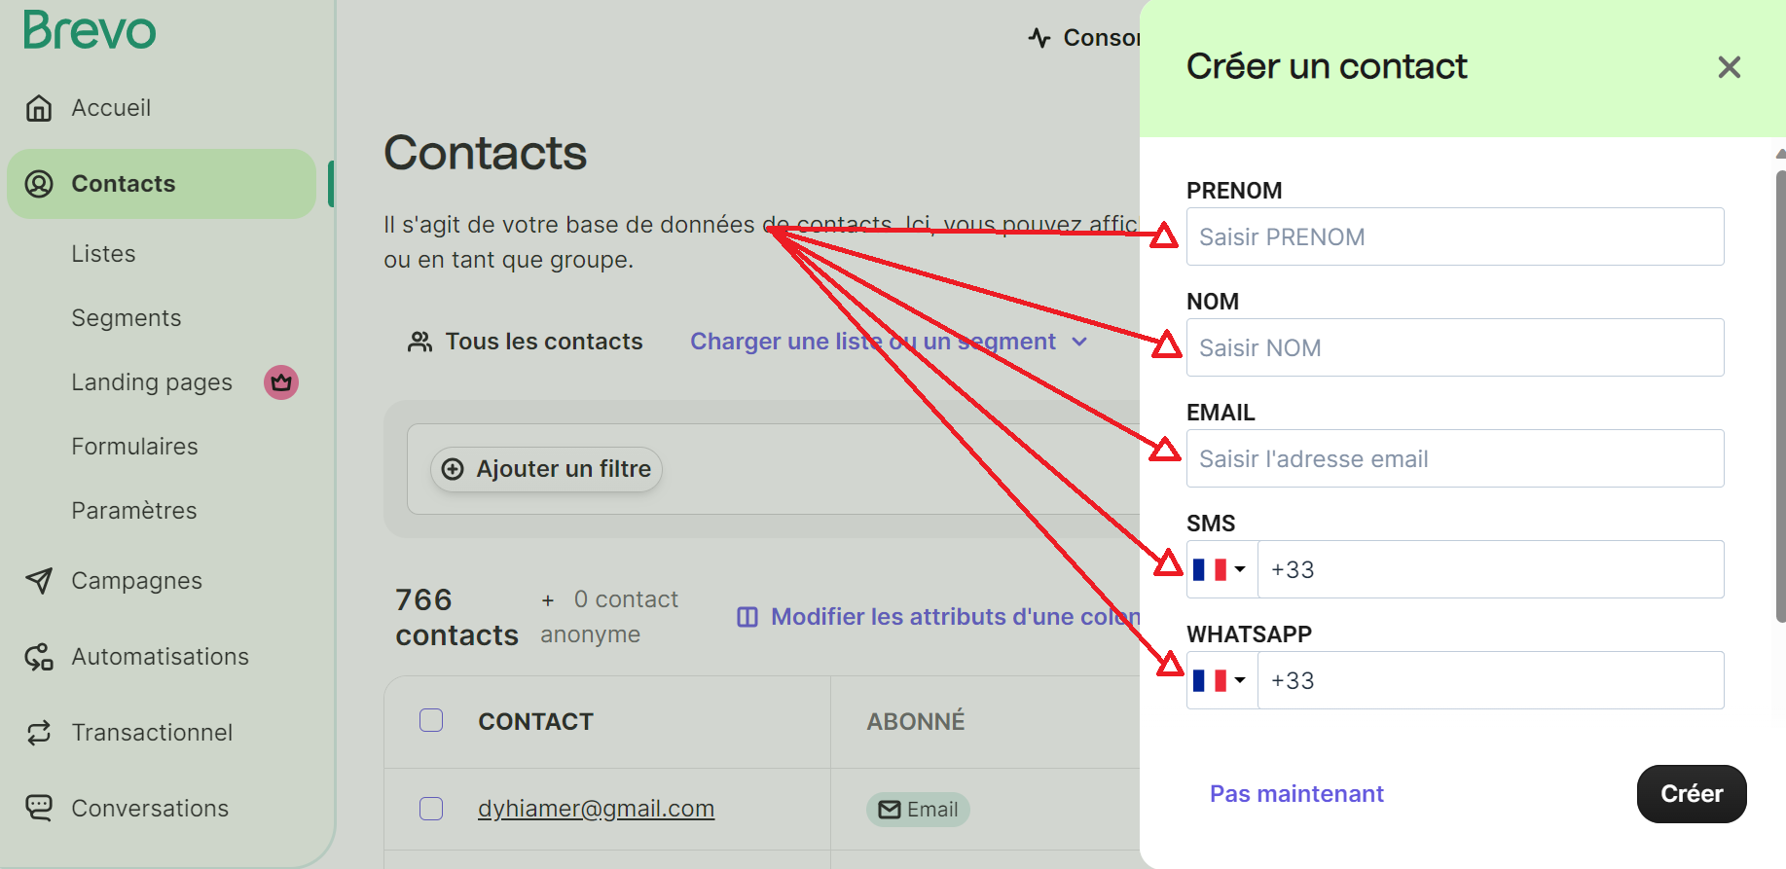

* Click on “Create”

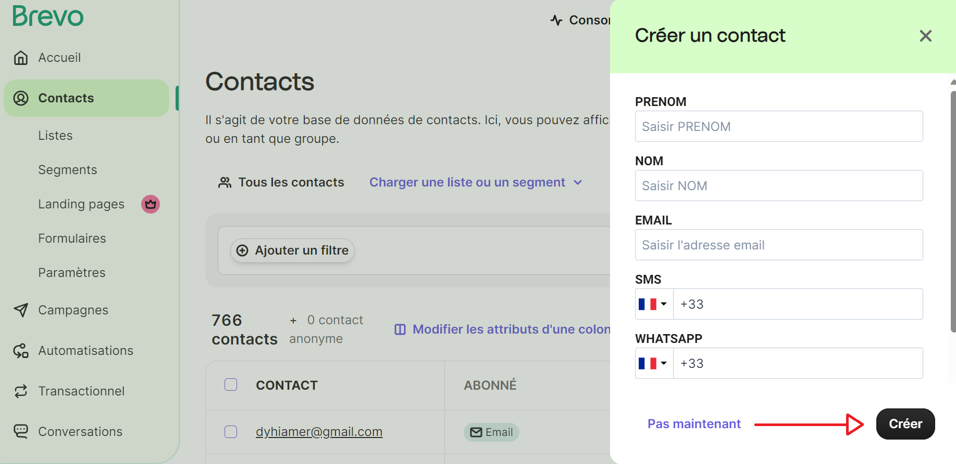

# Create a list

* From the home page: select “Contacts”



* Click on “lists”

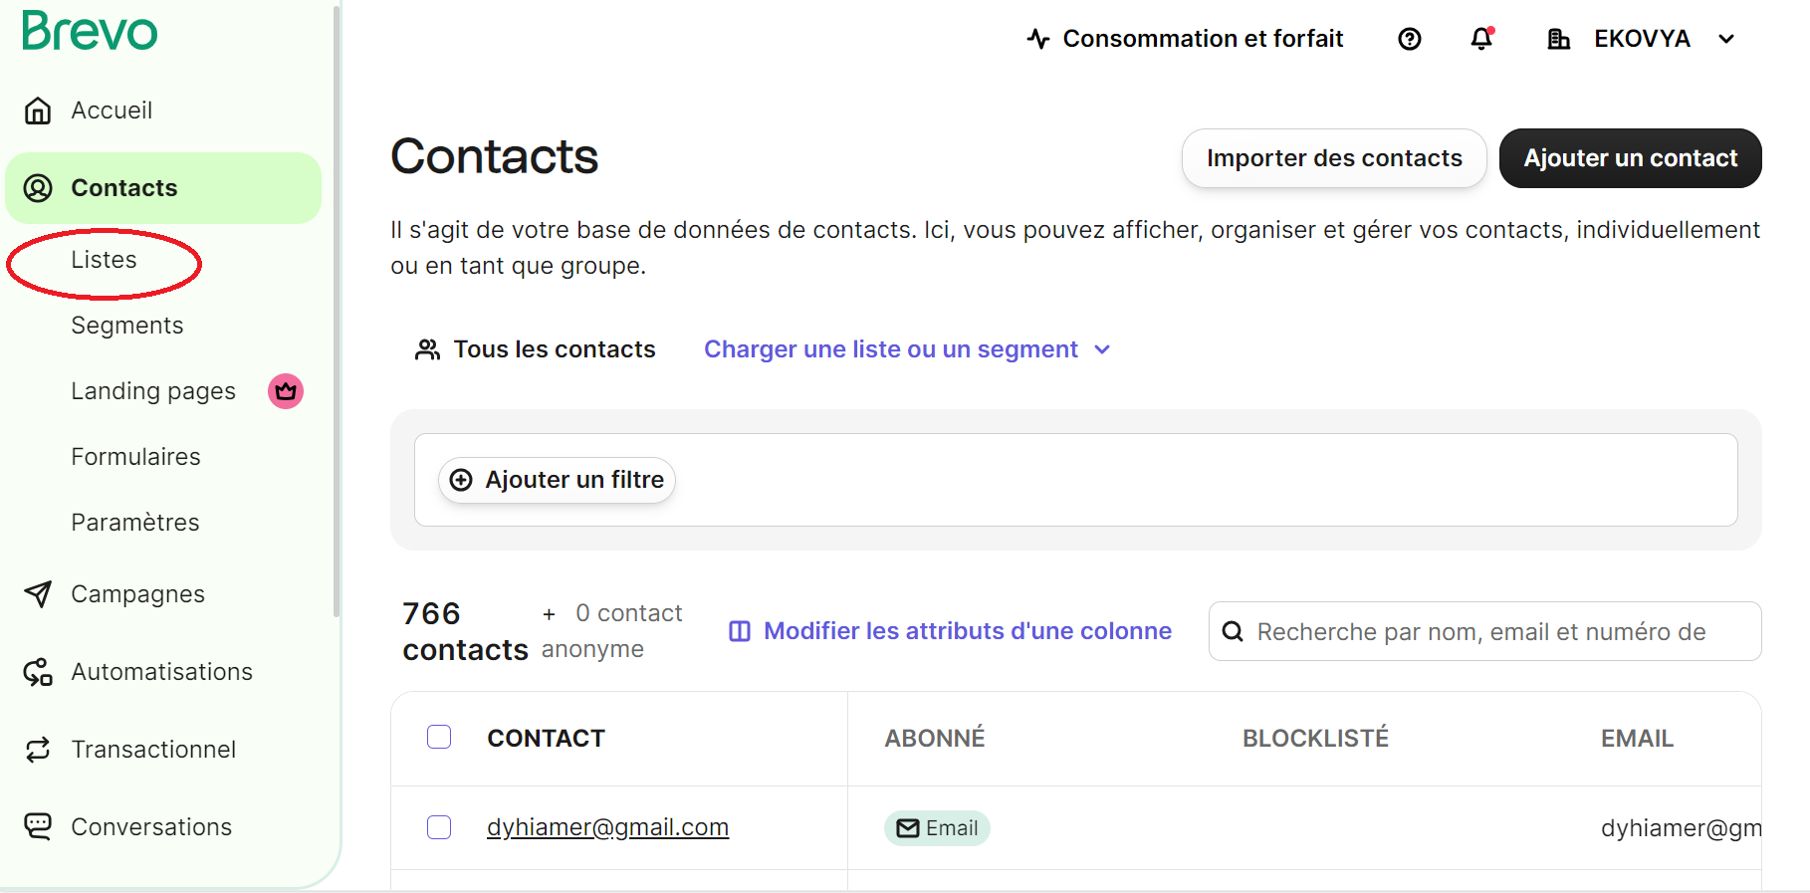

* Click on “Create a list”

# 

* On the pop-up page: Name the list and choose the folder needed
* Click on “Create a list”

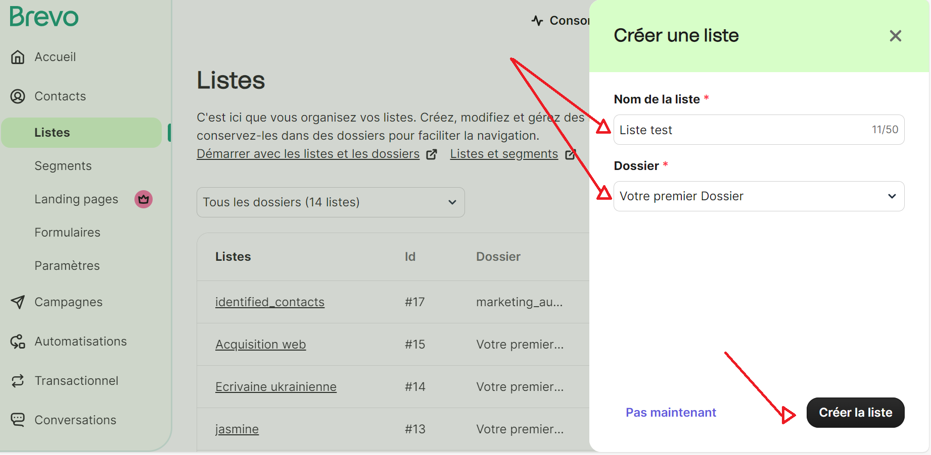

* The created list will be added to the page lists

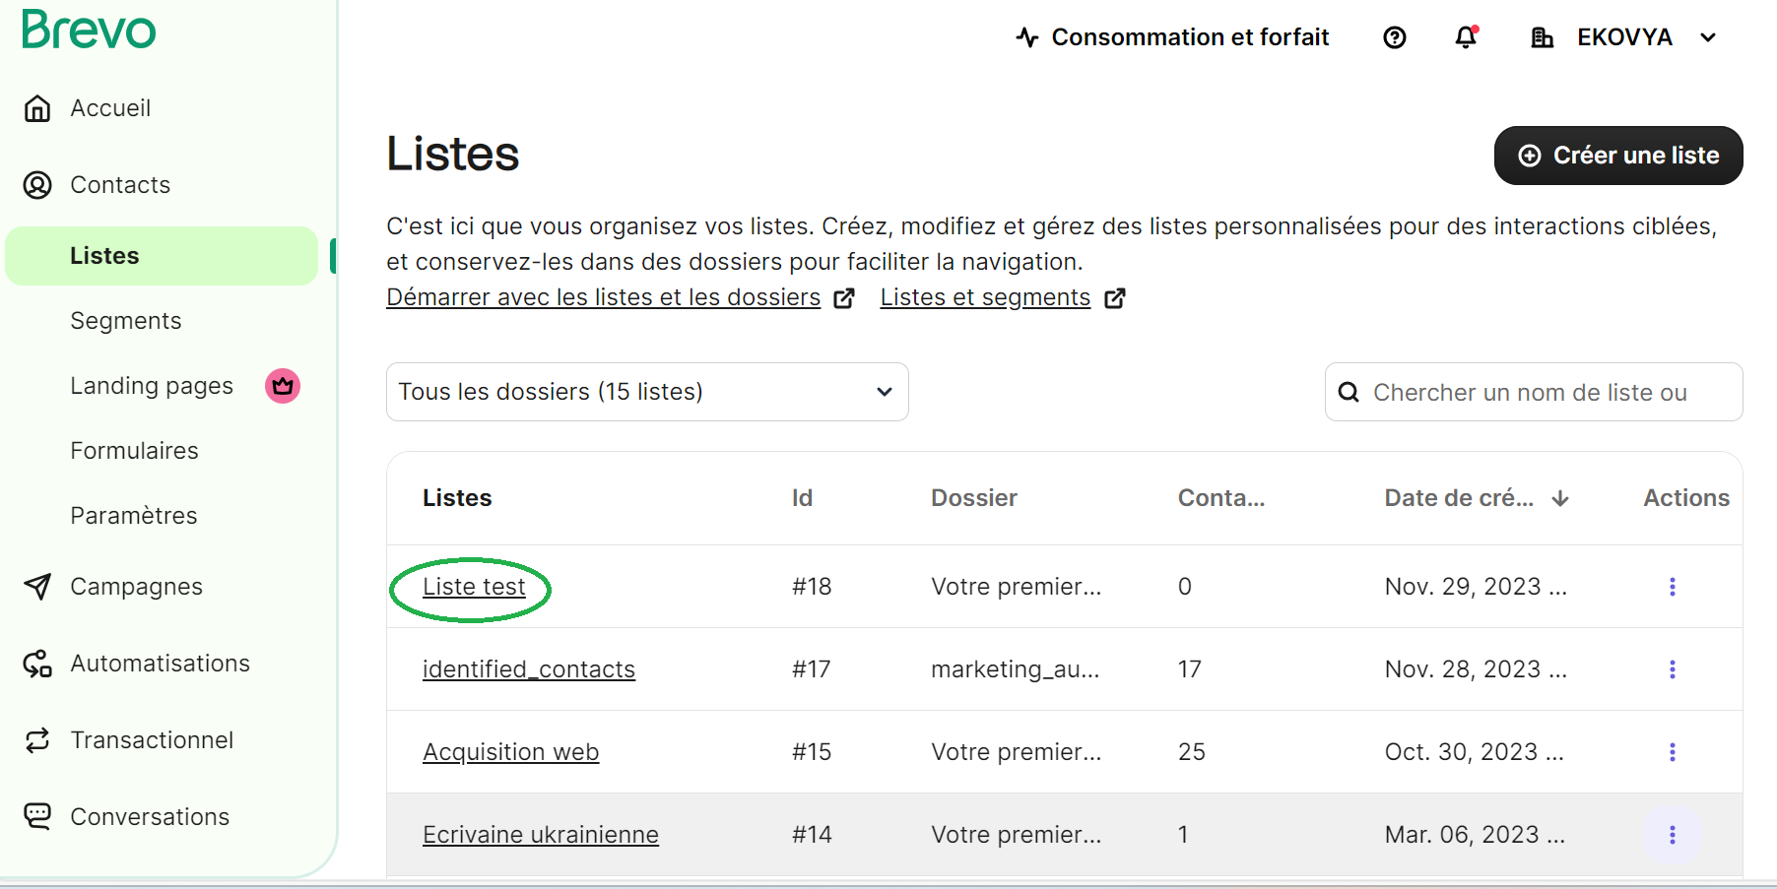

# Create a campaign

* From the home page: select “Campaigns”

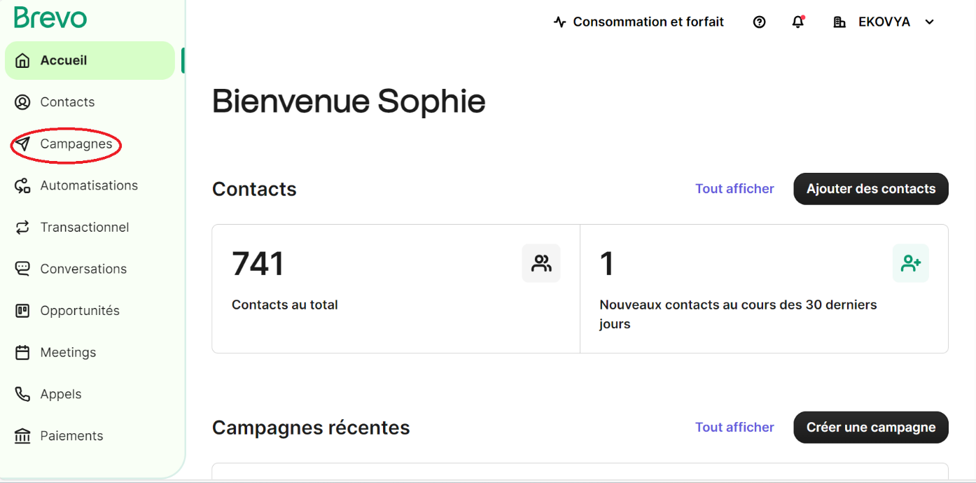

* Click on Create a “campaign”

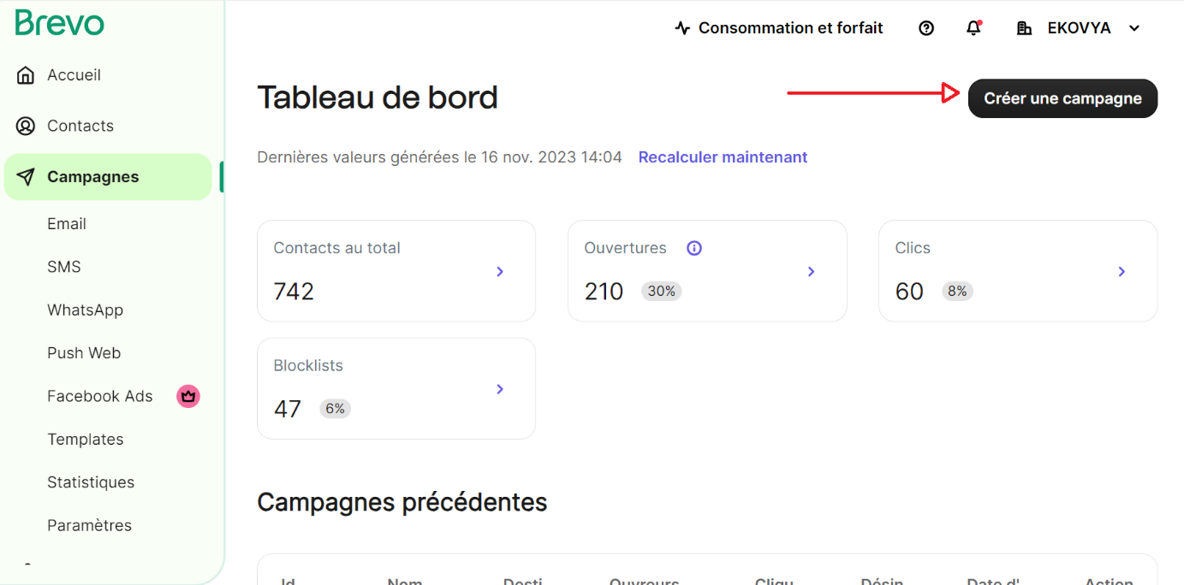

* On the pop-up page click on “Email”

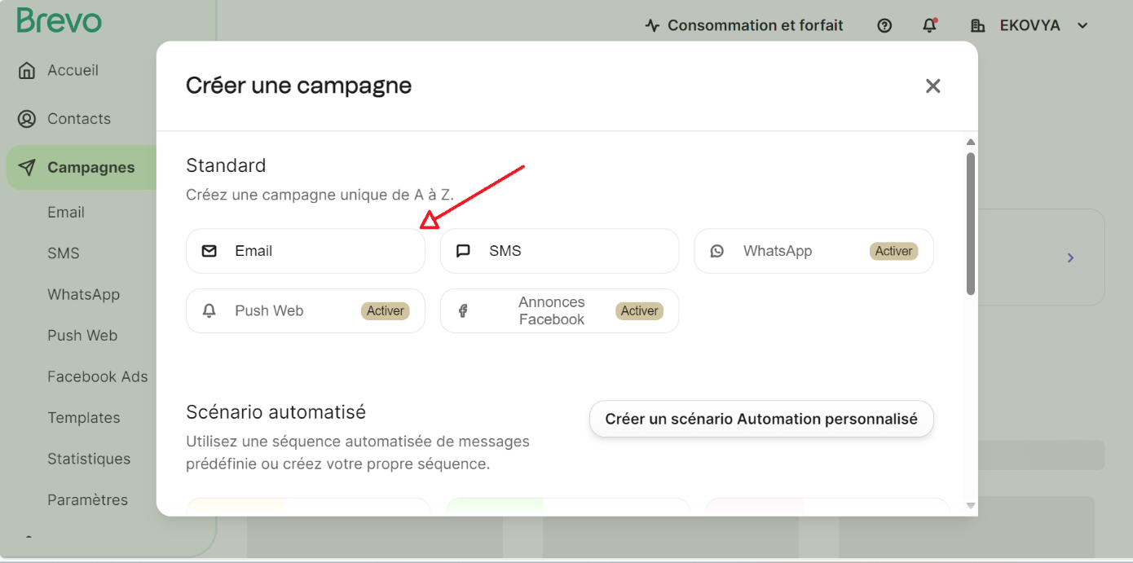

* Choose a name for your campaign (required) and click on “Create a campaign” :

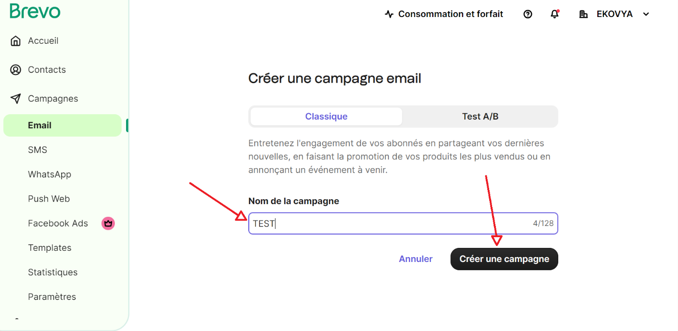

* On this new page, you can customize your email:
* Add necessary information: from, to, subject, design

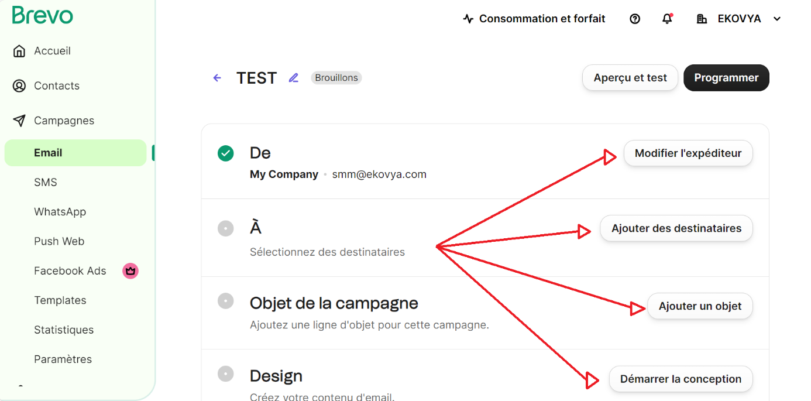

* To finish, click on “Program”

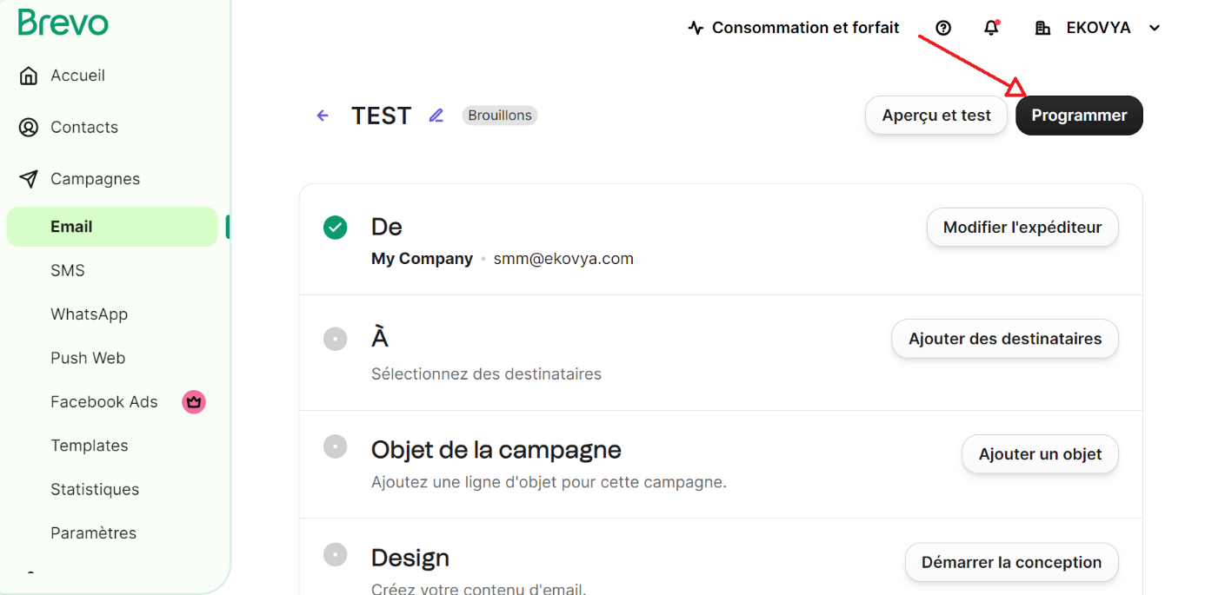

# Newsletter

* From the home page: select “Forms”
* Select “Create a new form”

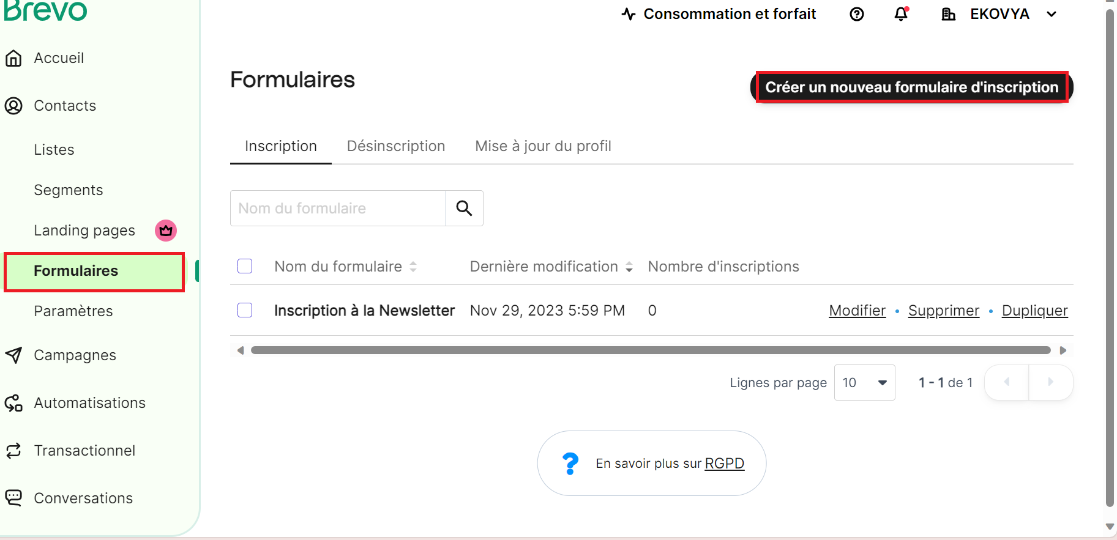

* Customize the Newsletter by using the bloks under Conception

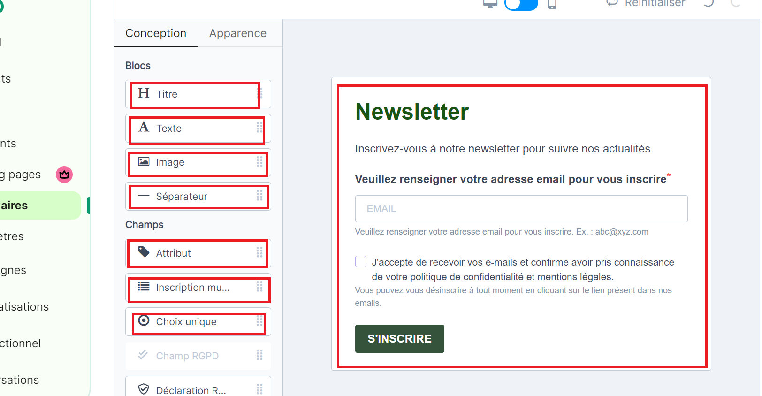

* Select a list by checking the boxes
* Or create a new one

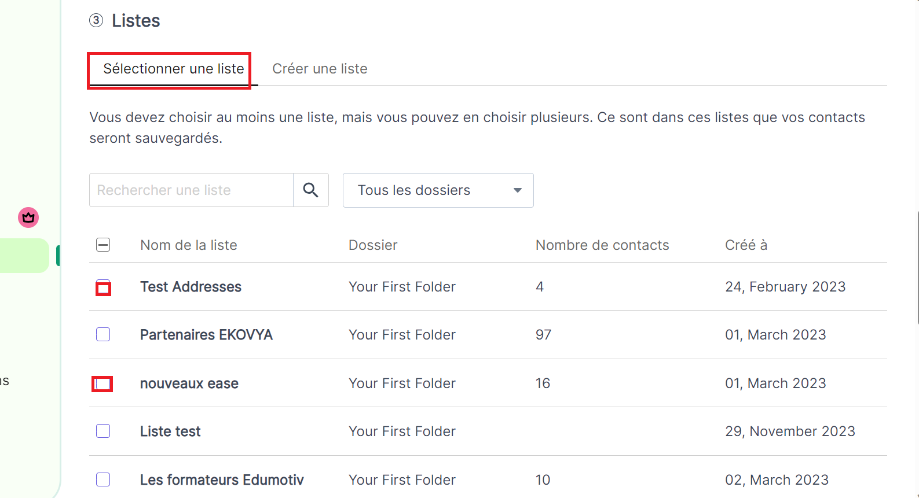

* Customize the messages to recieve by the customer
* Click on “Next”

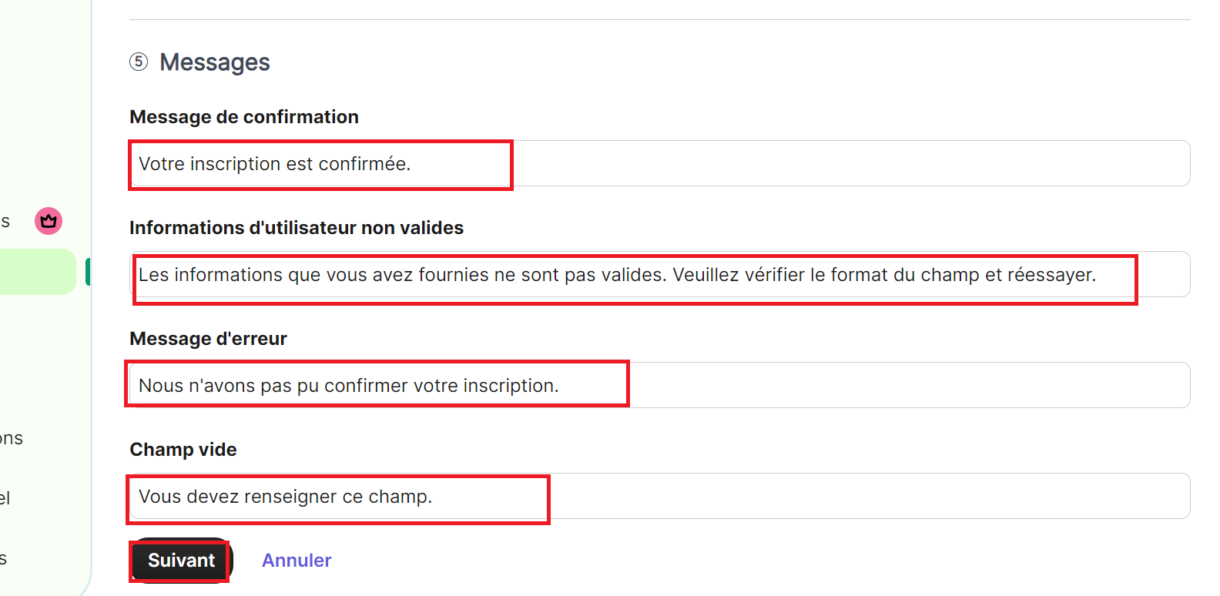

* Copy the HTML code to insert it in a Wordpress page
* Click on “Finish”

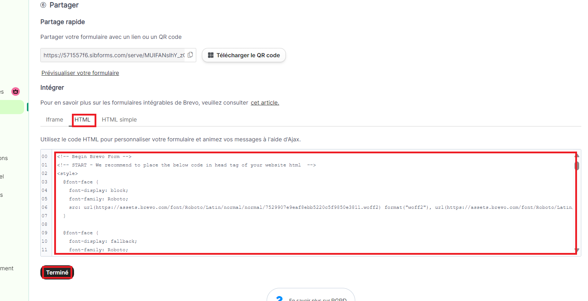

* In Wordpress home page
* Select “Pages”

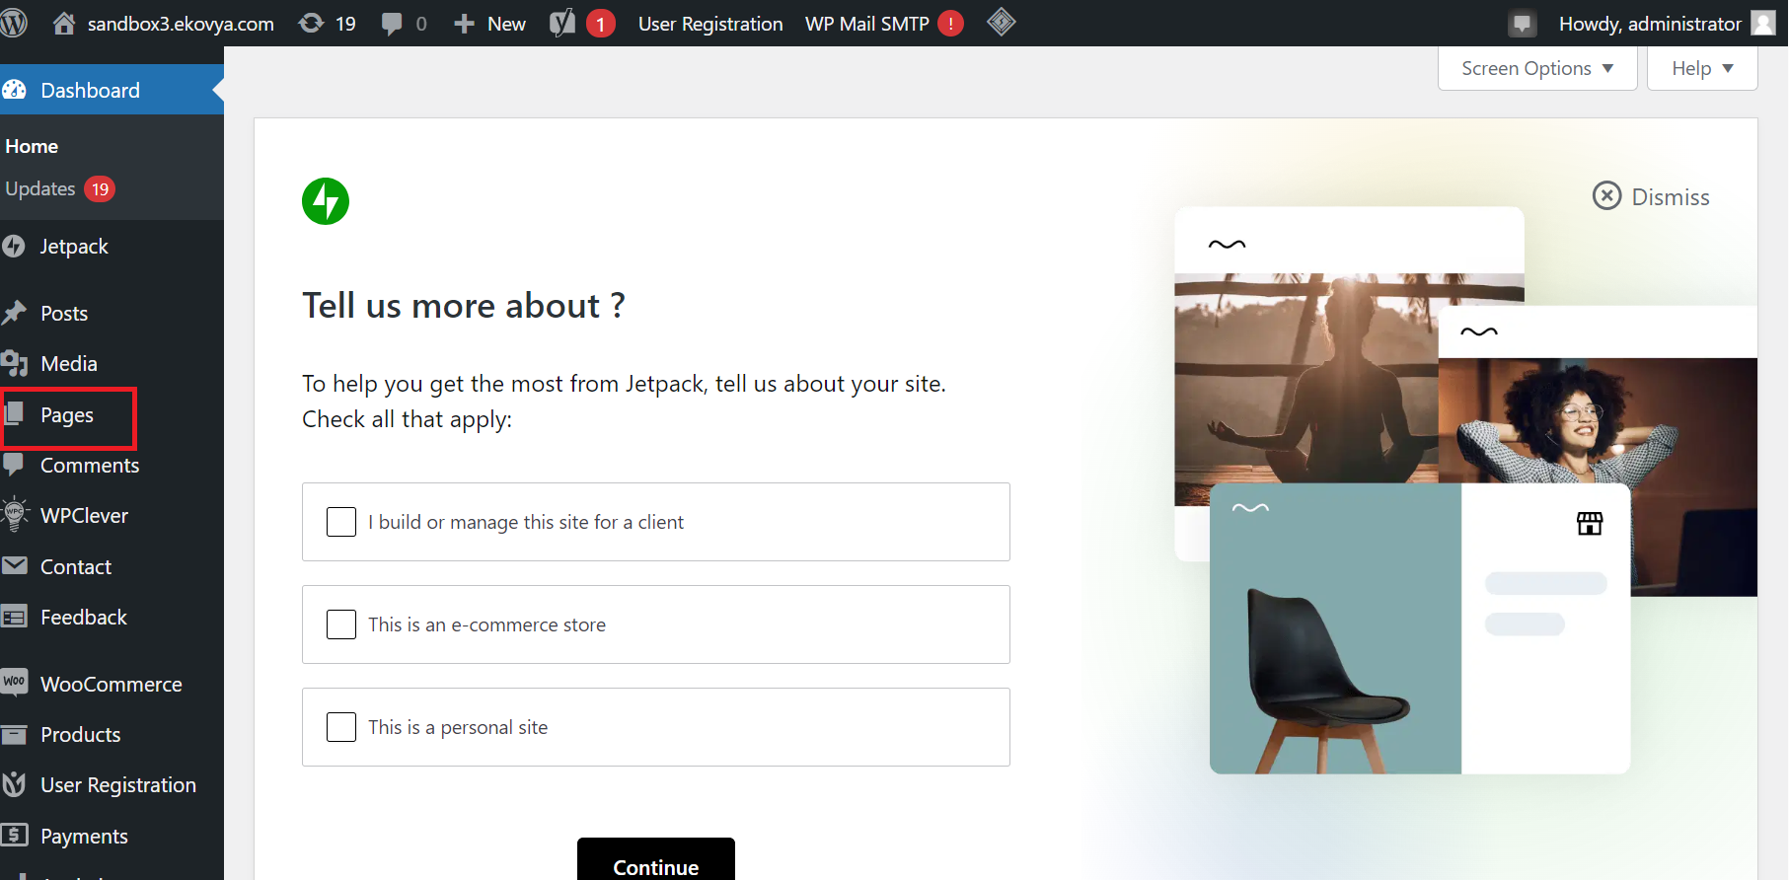

* Select “All pages” if the page already exists
* Or “Add new page” to create a new page

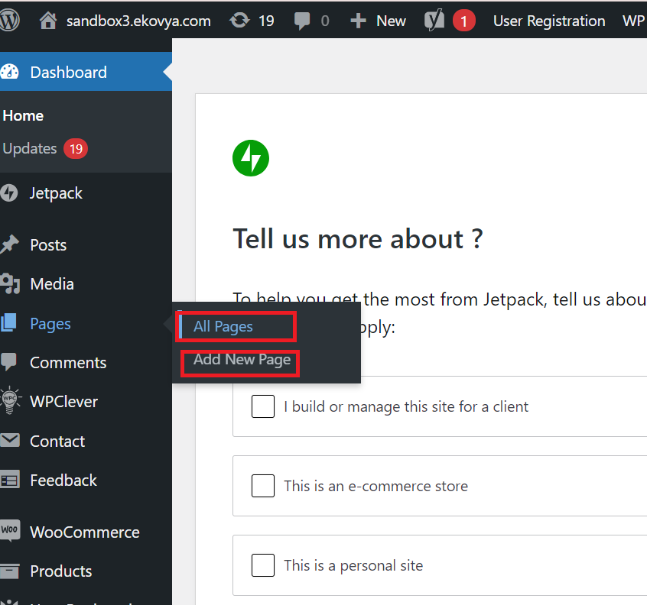

* Choose the page needed to modify in Elementor
* In this case, select the Newsletter page

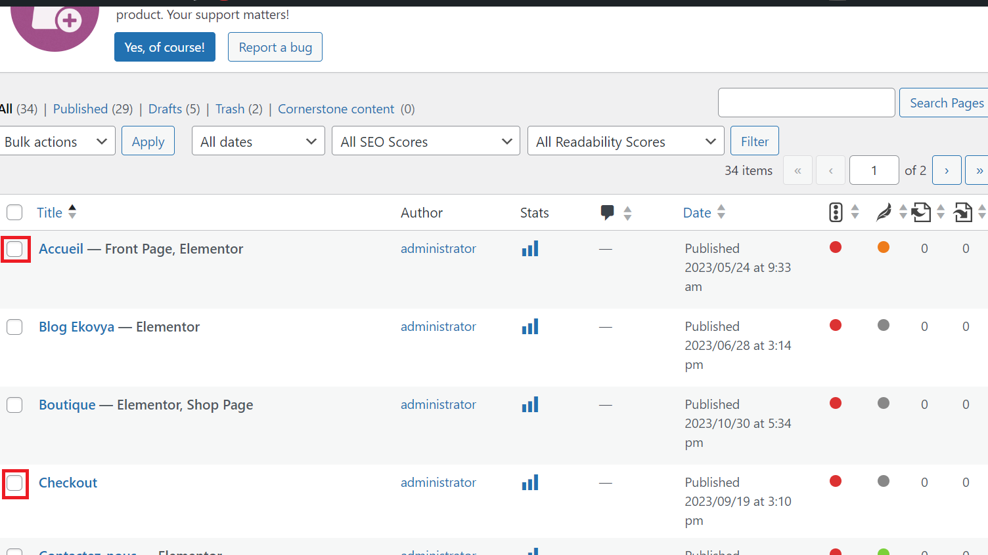

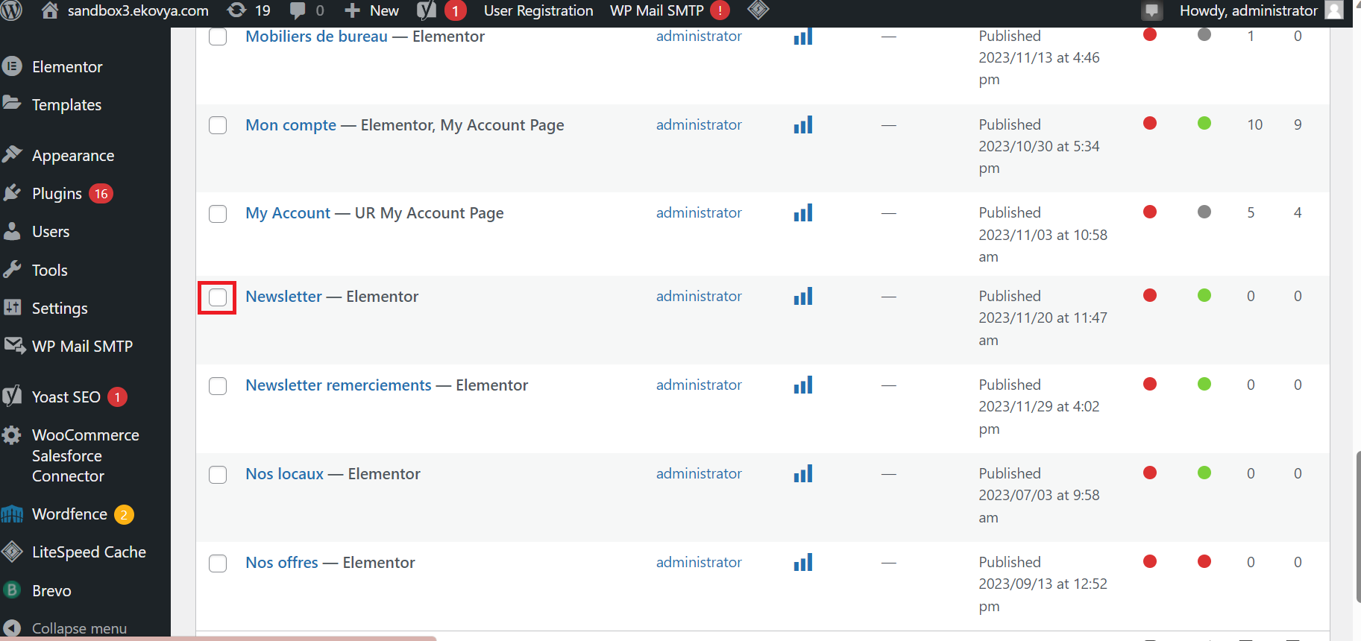

* Click on “Edit with Elementor”

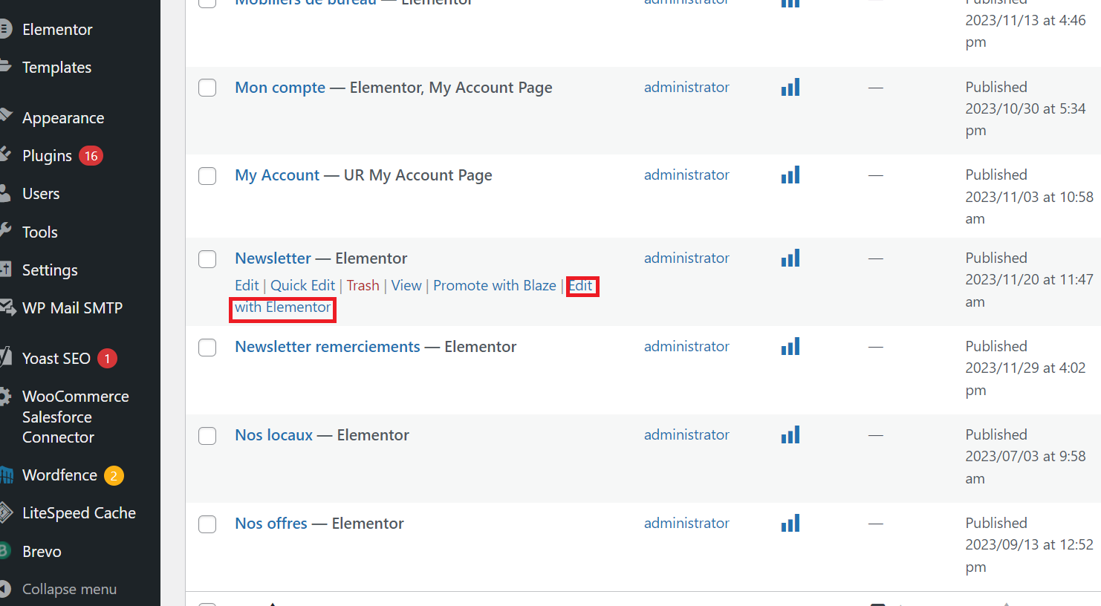

* Get to the page Elementor
* Click on the “+”, as in the picture below, to choose a content

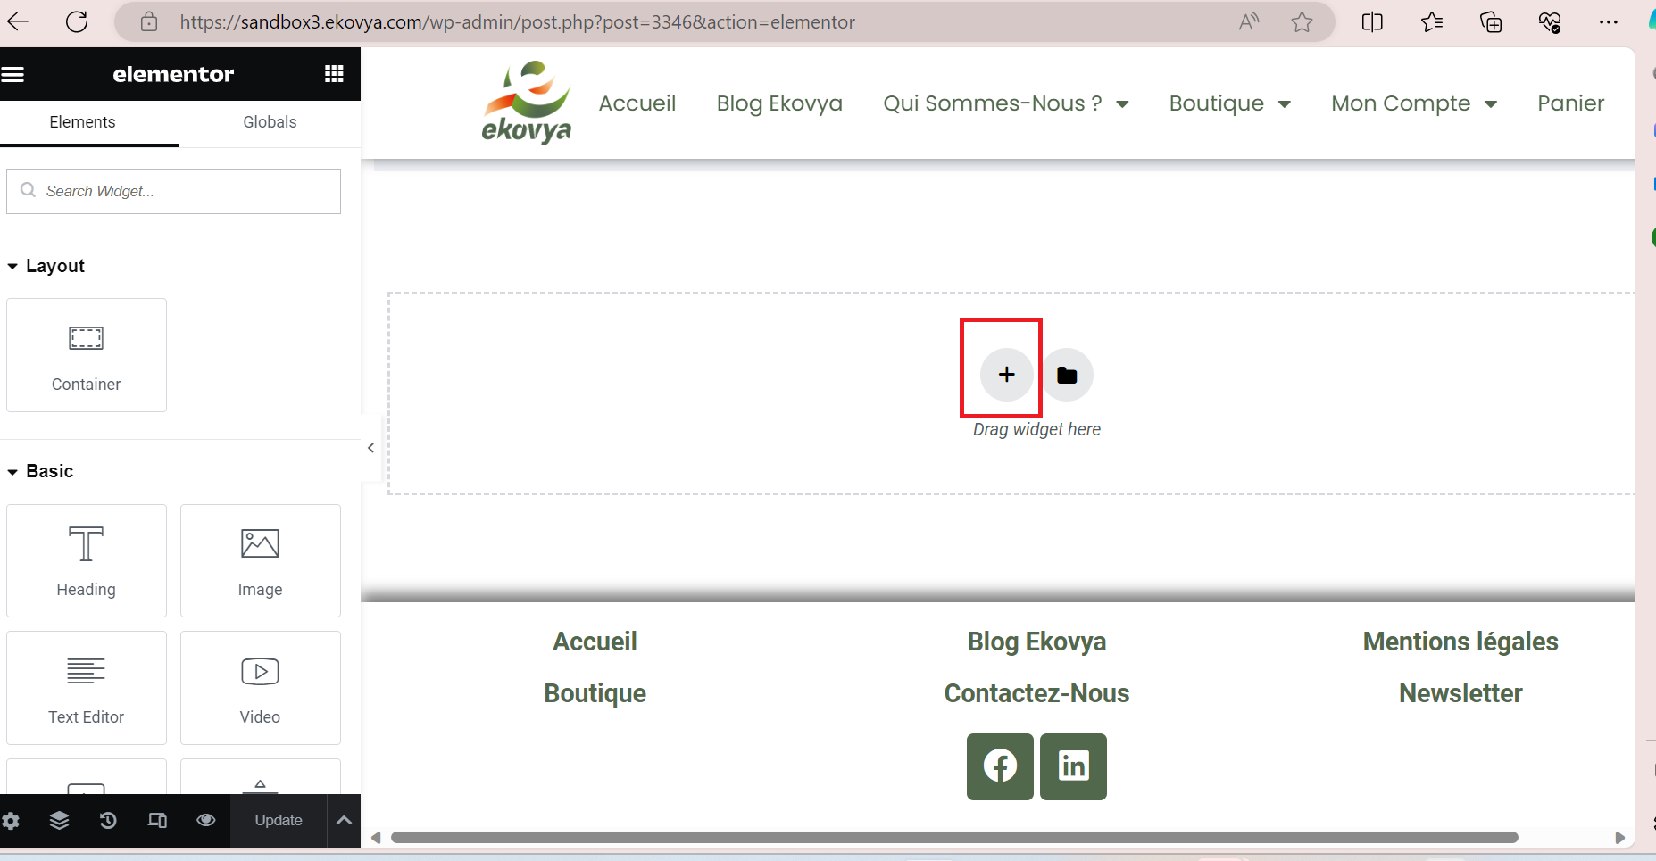

* Select a structure needed

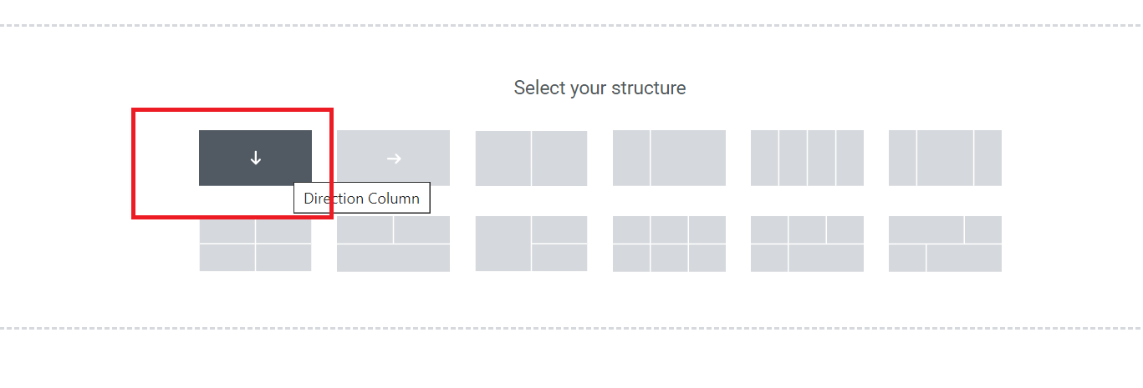

* Click on the “+” inside the content

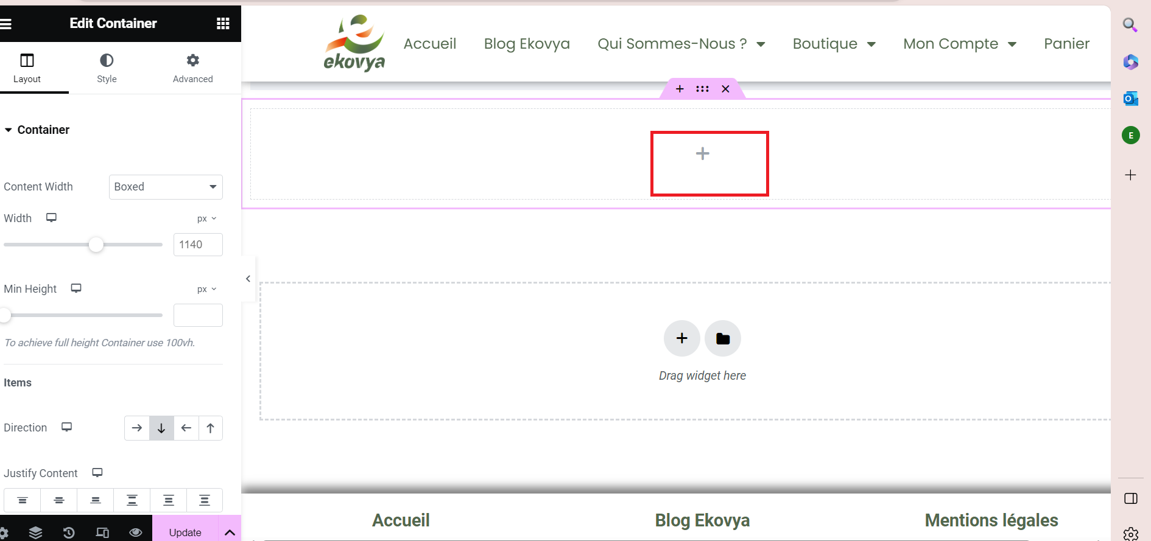

* Type HTML in the search bar and select HTML

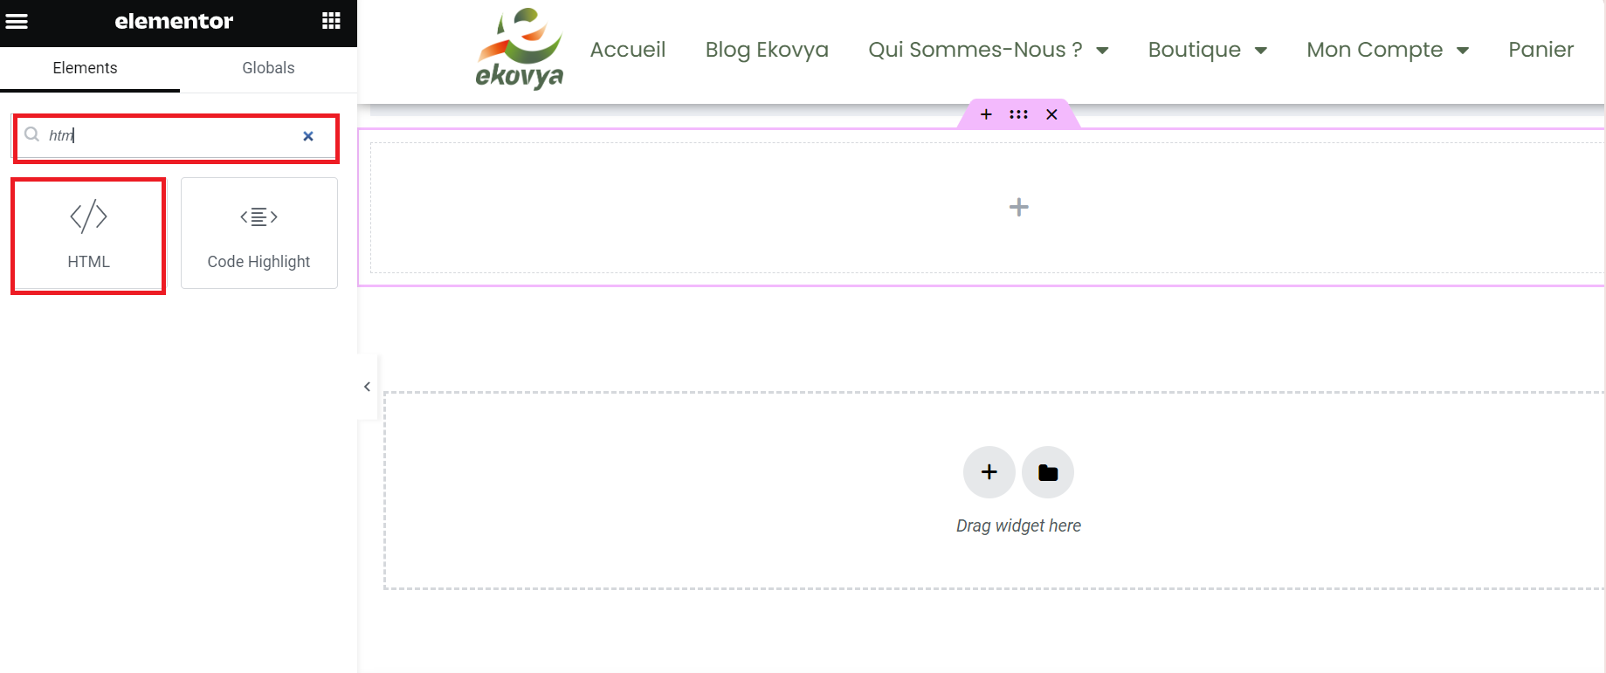

* Paste the HTML code
* Edit the code if needed
* Click on Update to publish the Newsletter

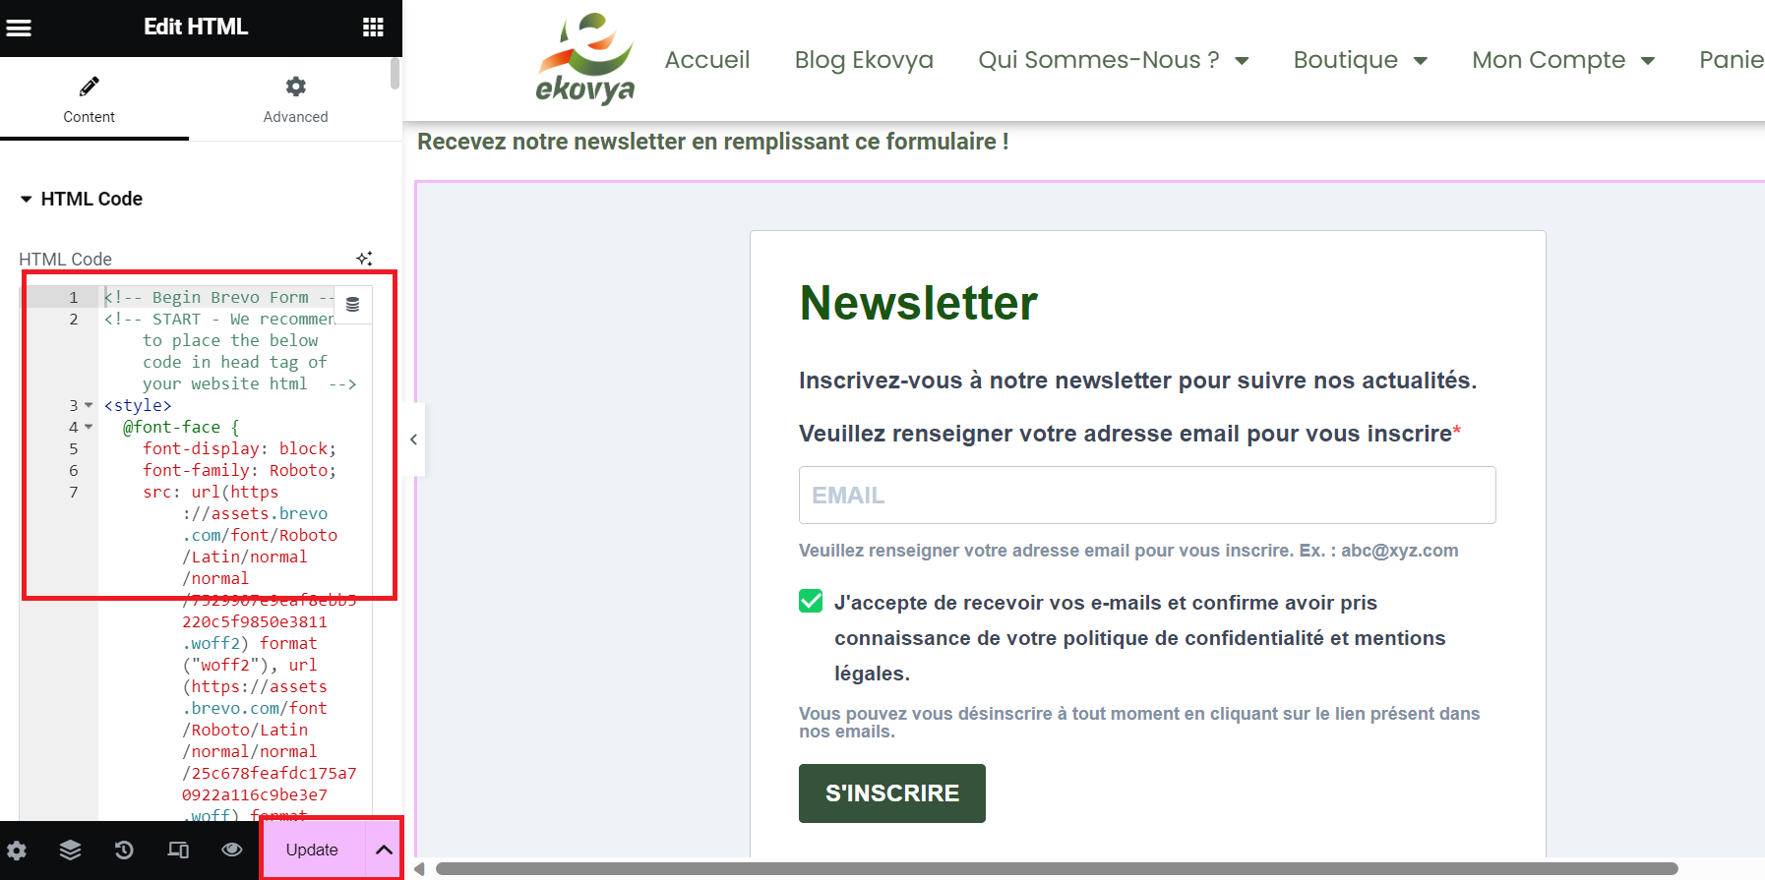

# Create an email template

* From the home page: select “

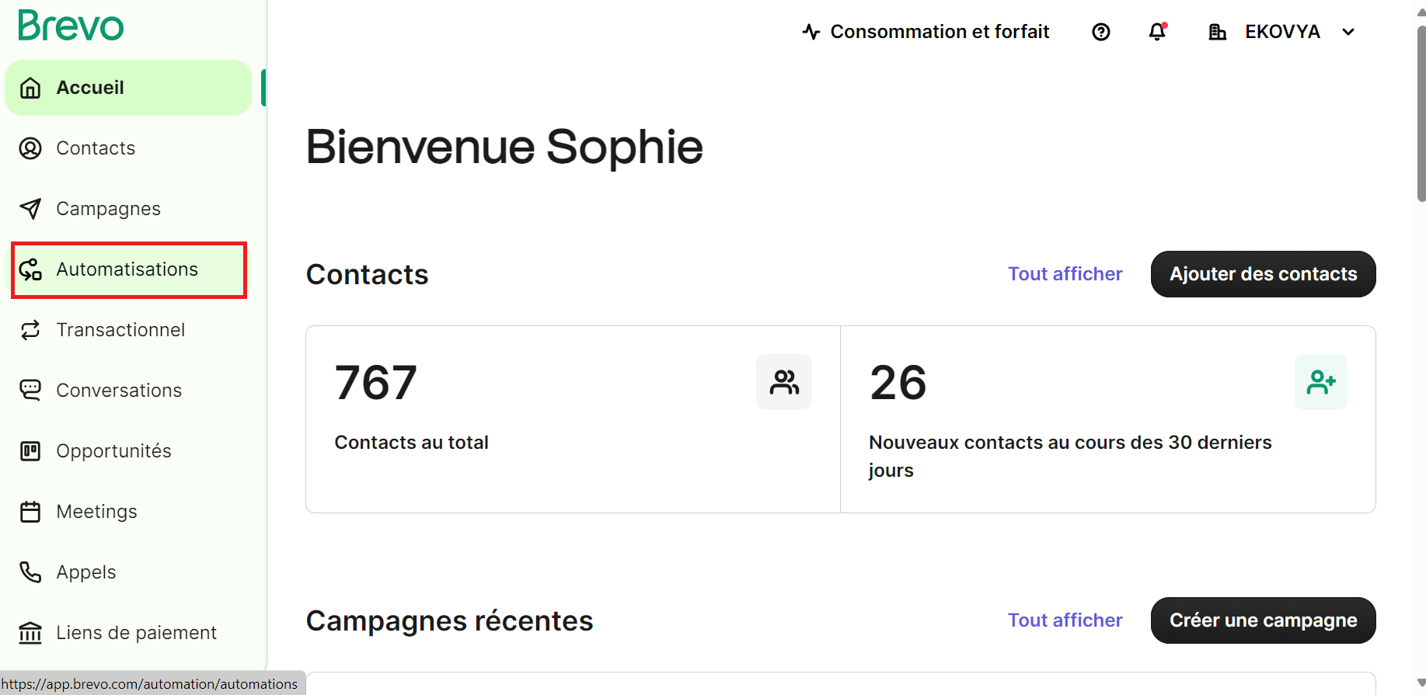

* Select “email templates”
* Click on “New template”

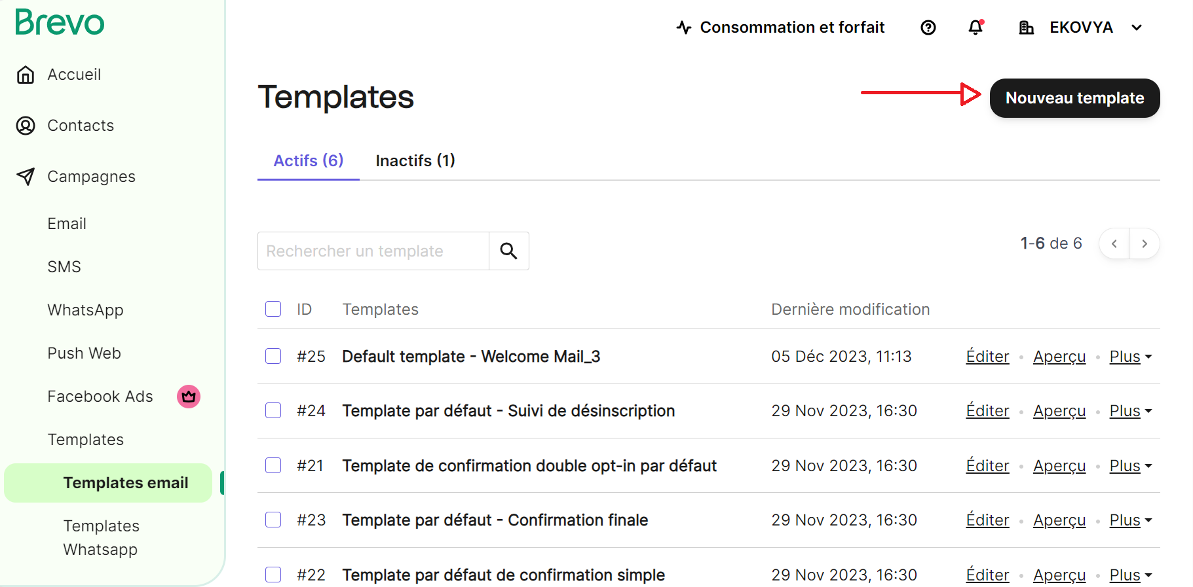

* Name the template
* Customize the object

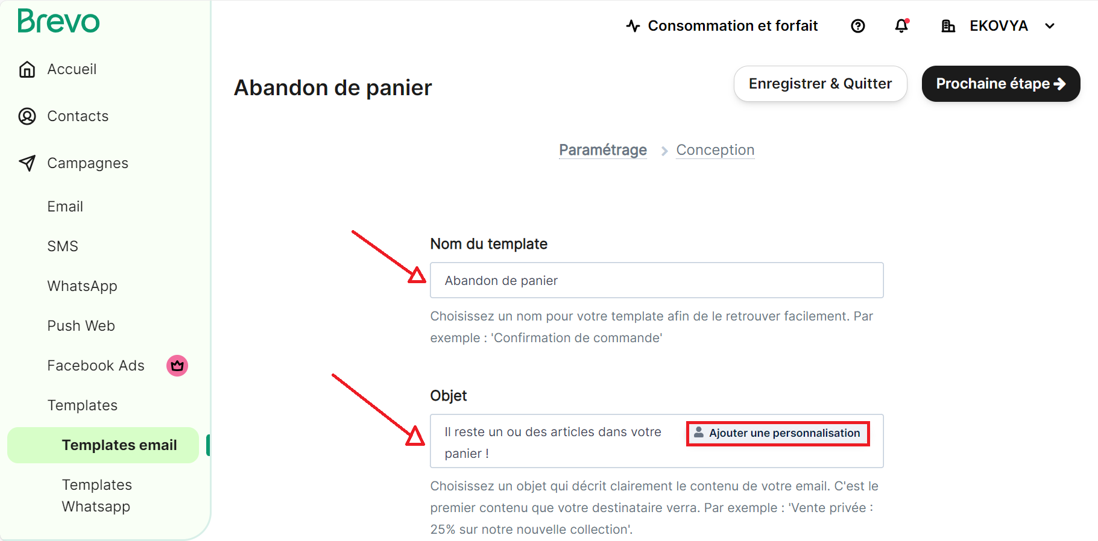

* Enter the details needed to be indicated in the email body: Name of the prospect, name of the product ...

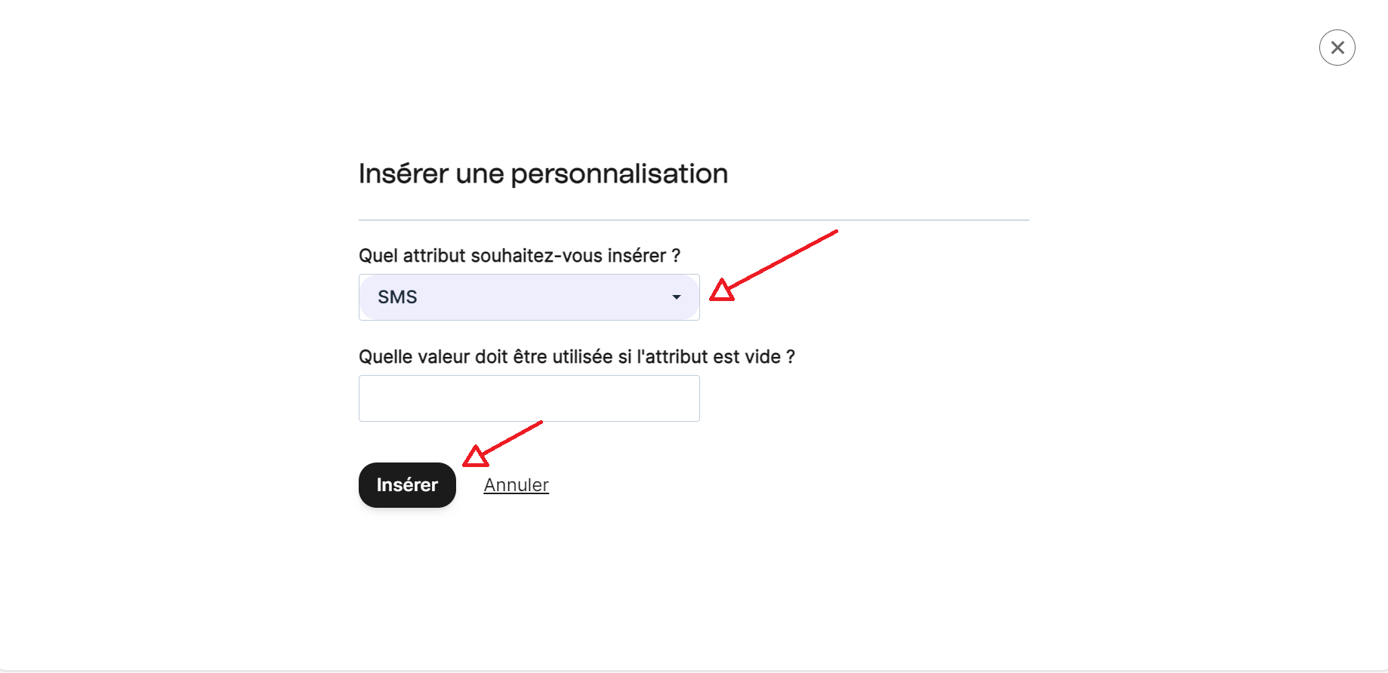

* Click on “Next step”

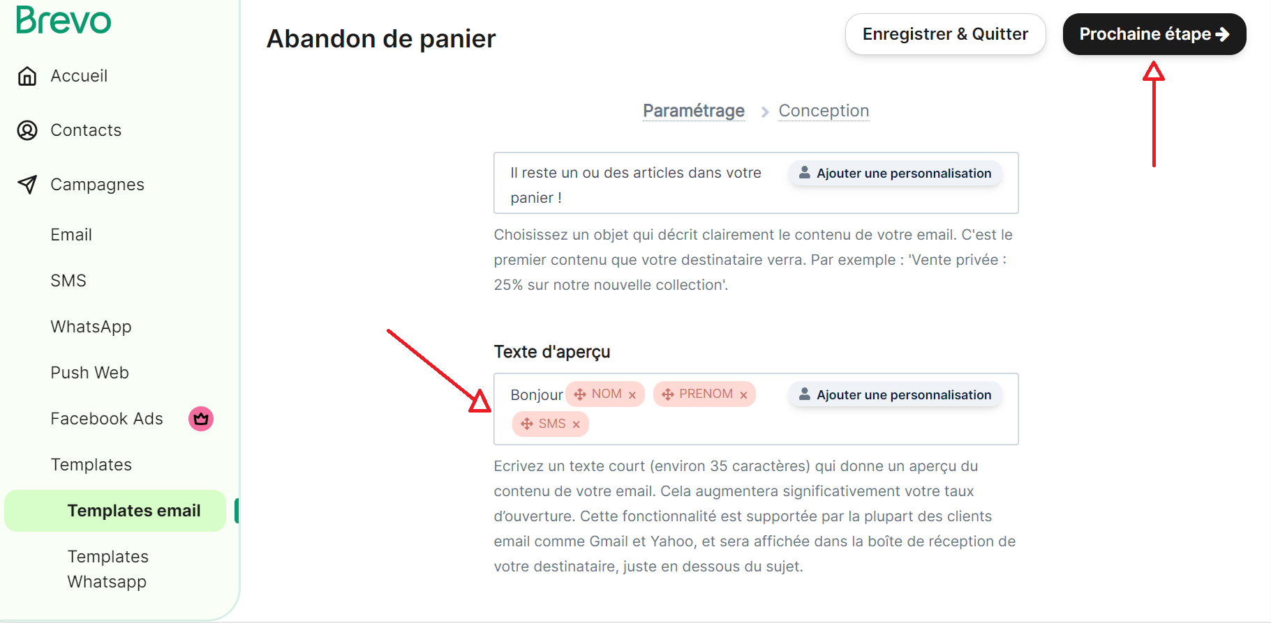

* Enter the sender and the email

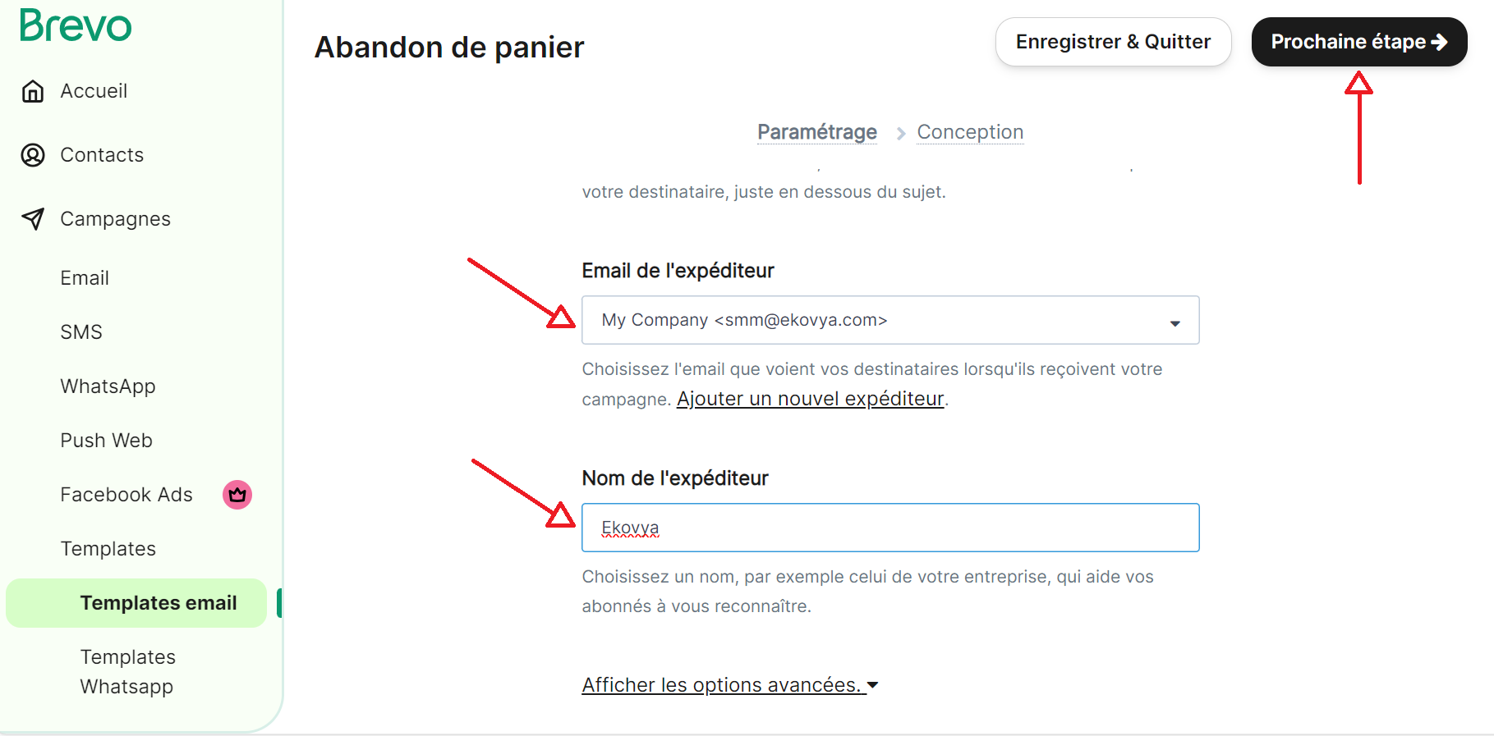

* Choose the appropriate template

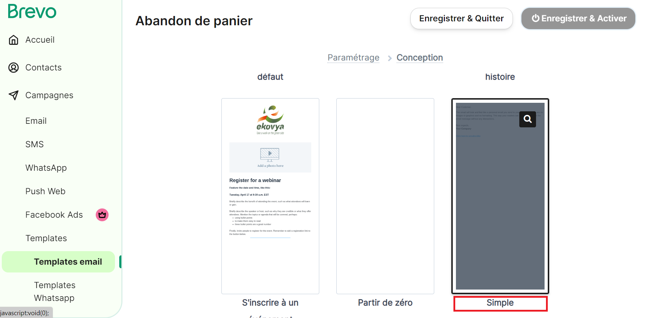

* Customize the text to send

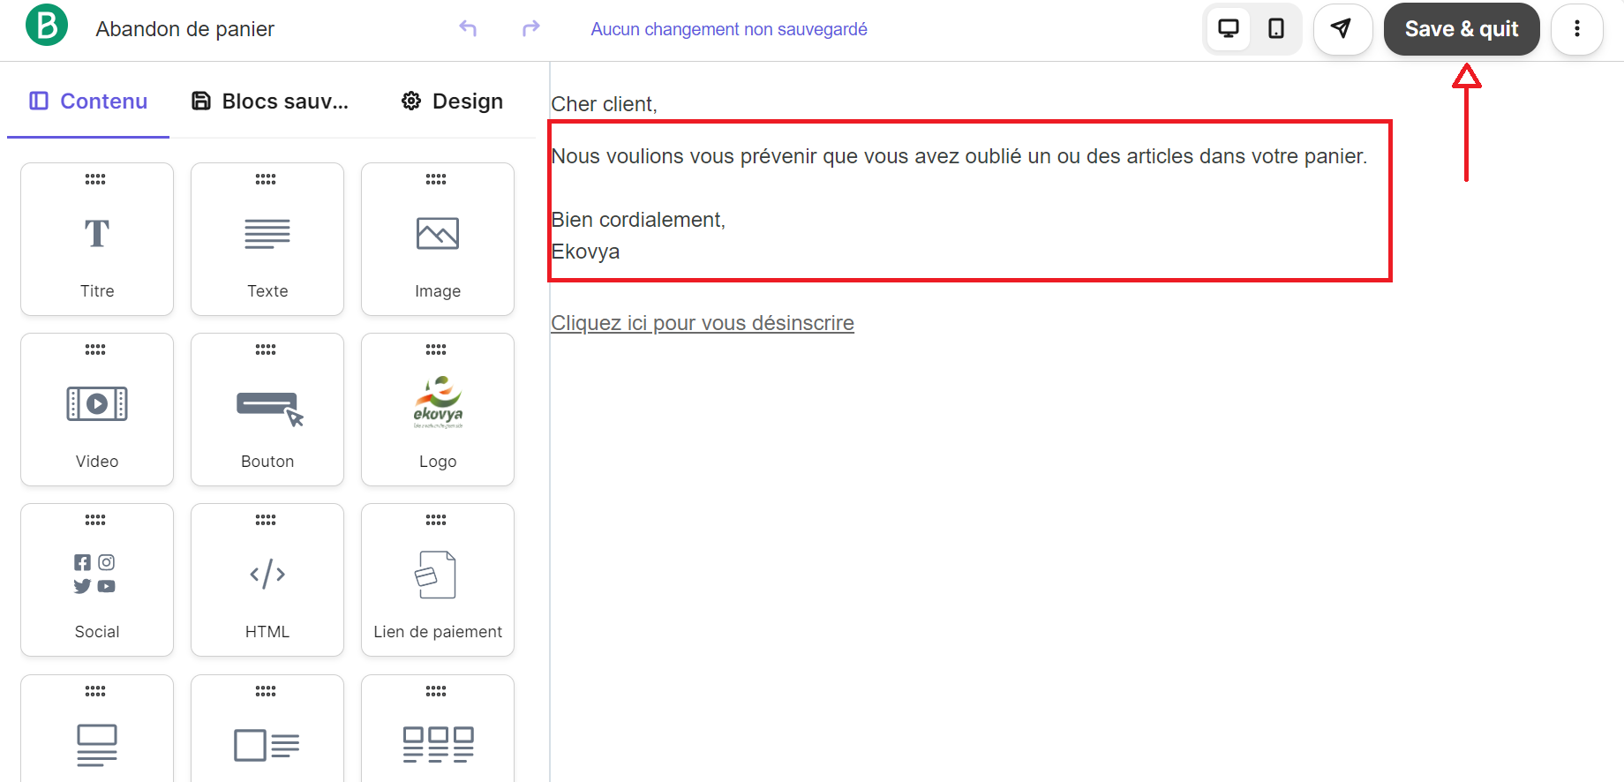

* Check the information
* Click on “Save and activate”

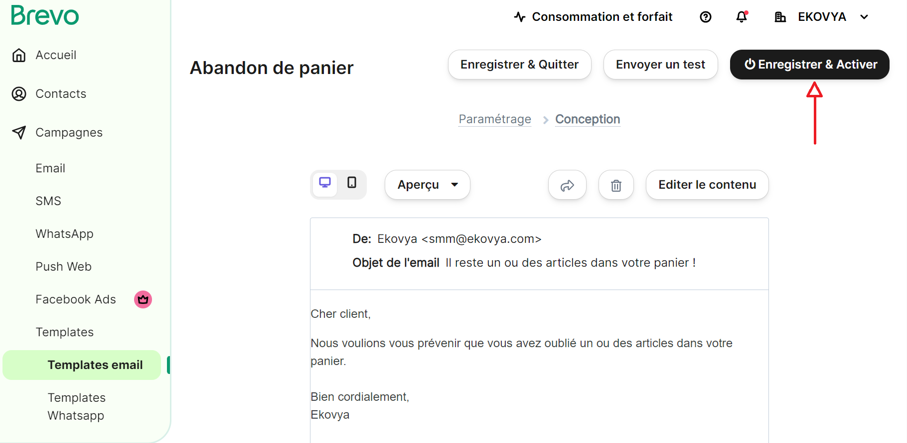

# Mailing automation

## Welcome email

When you have the list of the contacts, you can begin to automate a flow to send emails to the prospects and customers.

To create flows:

* From the home page: select “Automations”



* Click on “Create an automation”

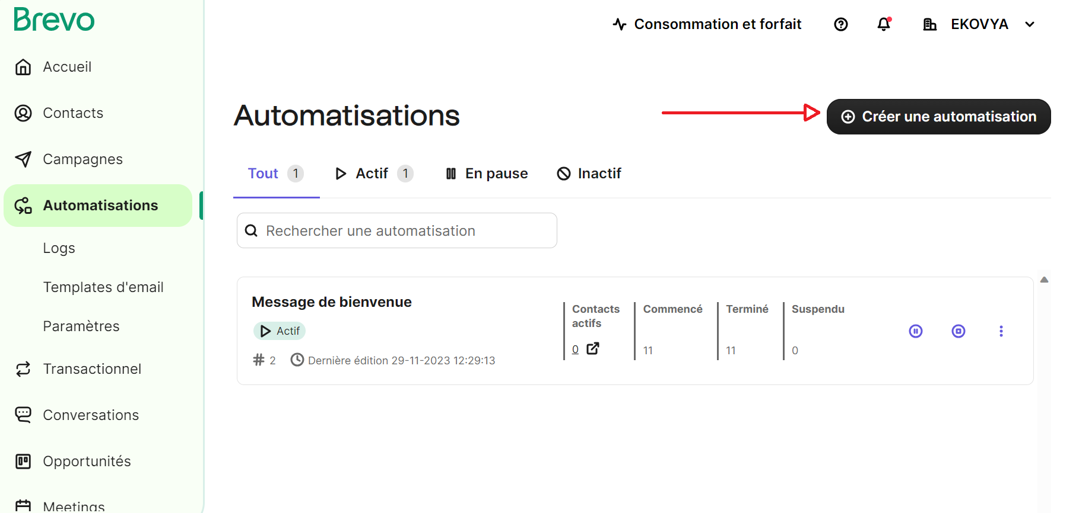

* Click on “Welcome message” to automate welcome mails

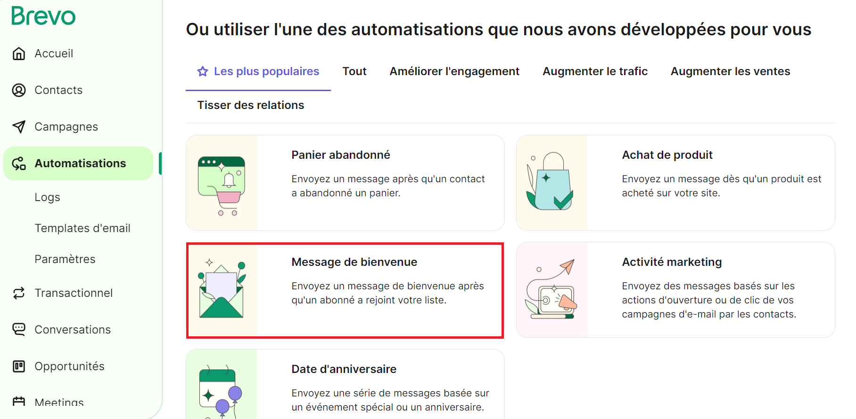

* On the popup: click on “use the flow”

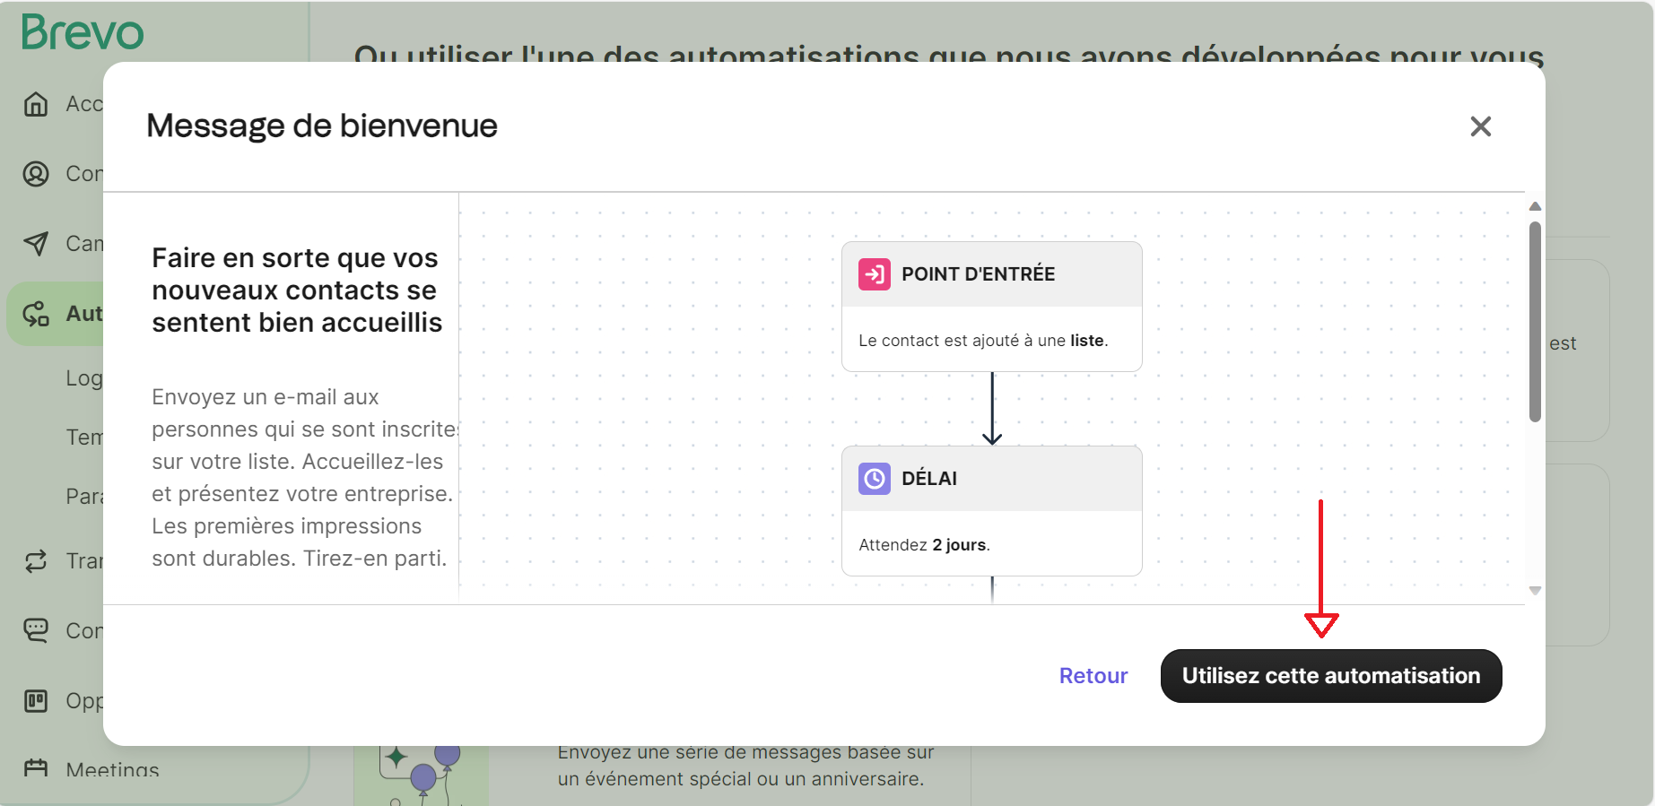

* Select a list

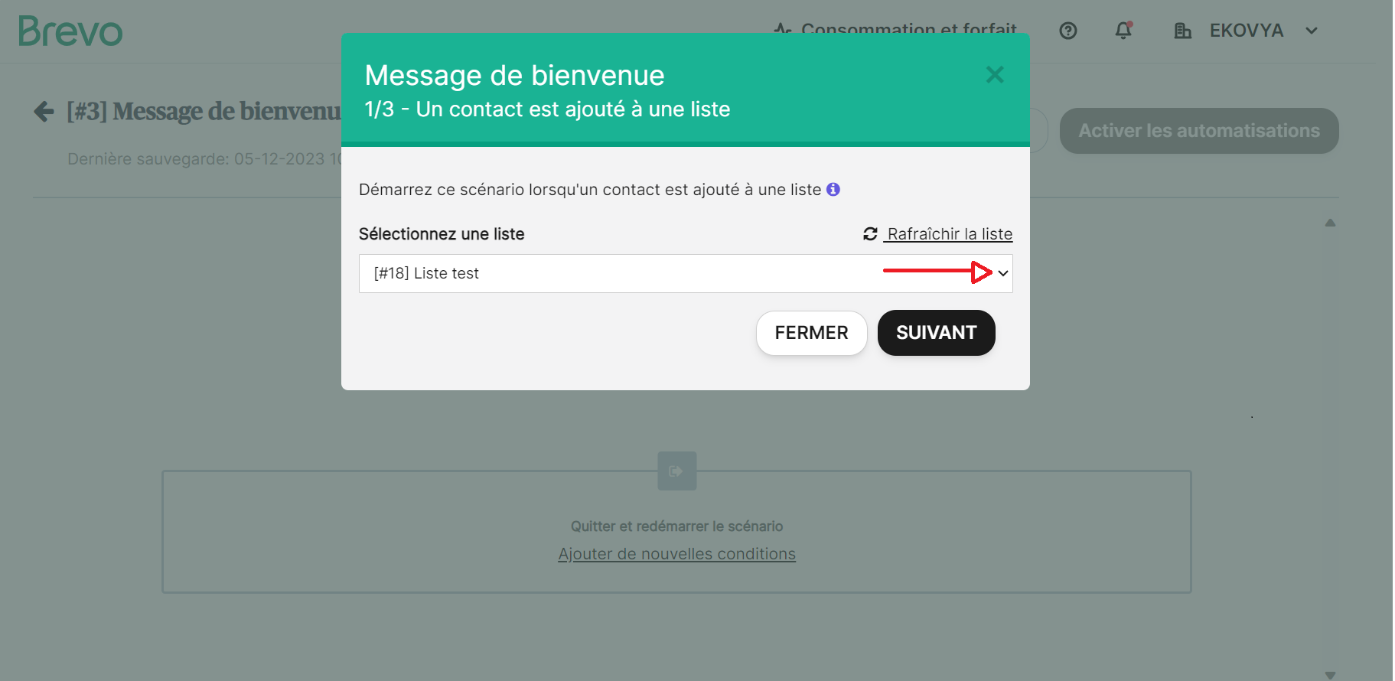

* Click on “Next”

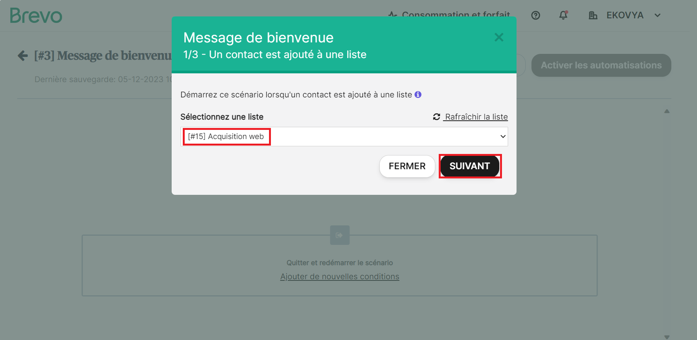

* Choose the appropriate time to send emails

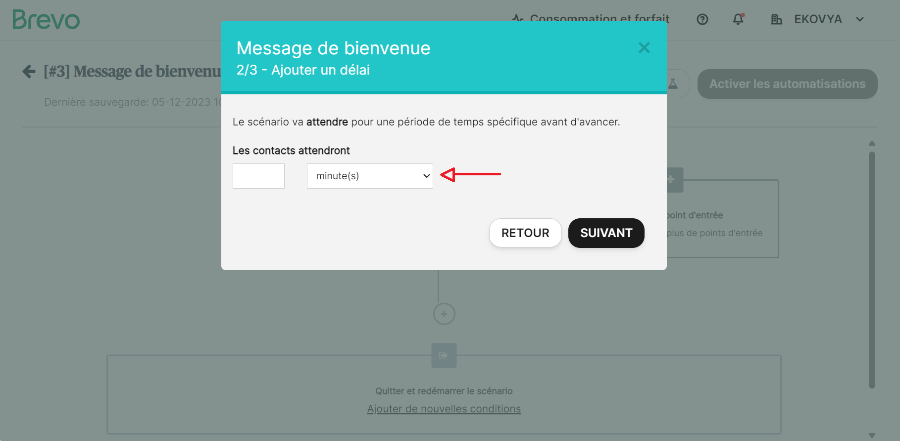

* Click on “Next”

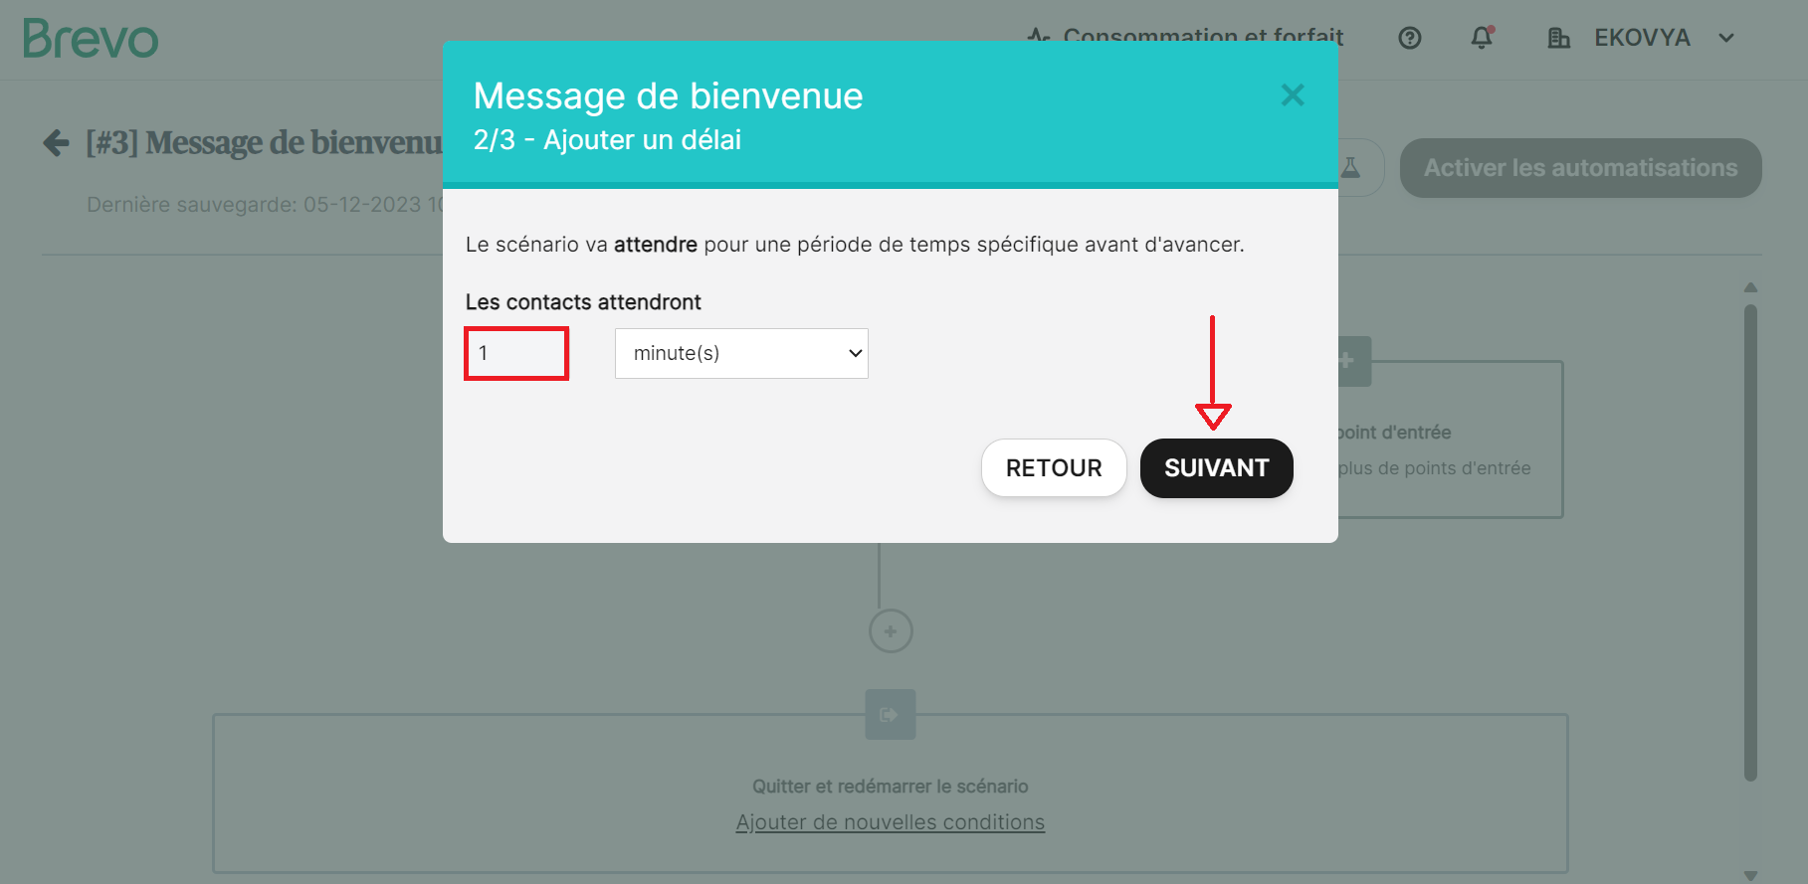

* Choose an email template to send to the appropriate public

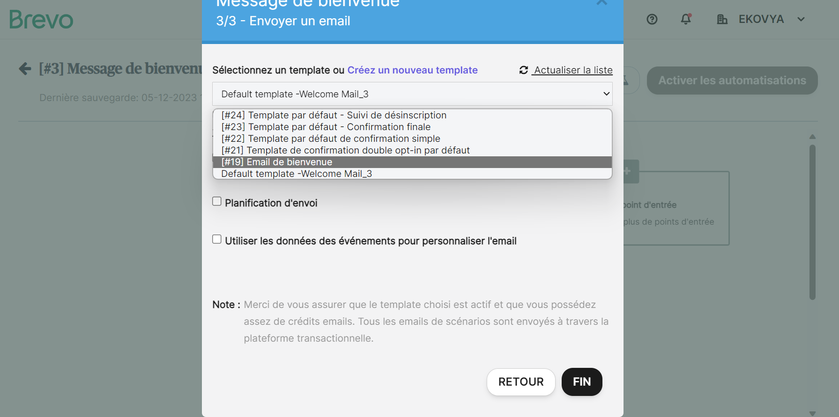

* Check the box: I want to send a copy of this email
* Enter the email address of the person who manages the campaigns

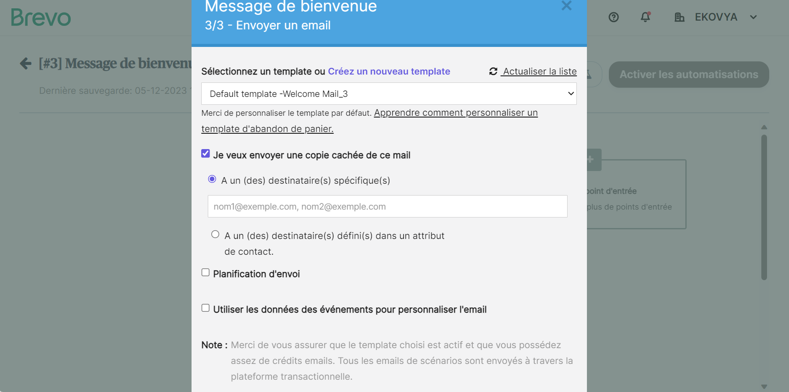

* To schedule email campaign: check the third box

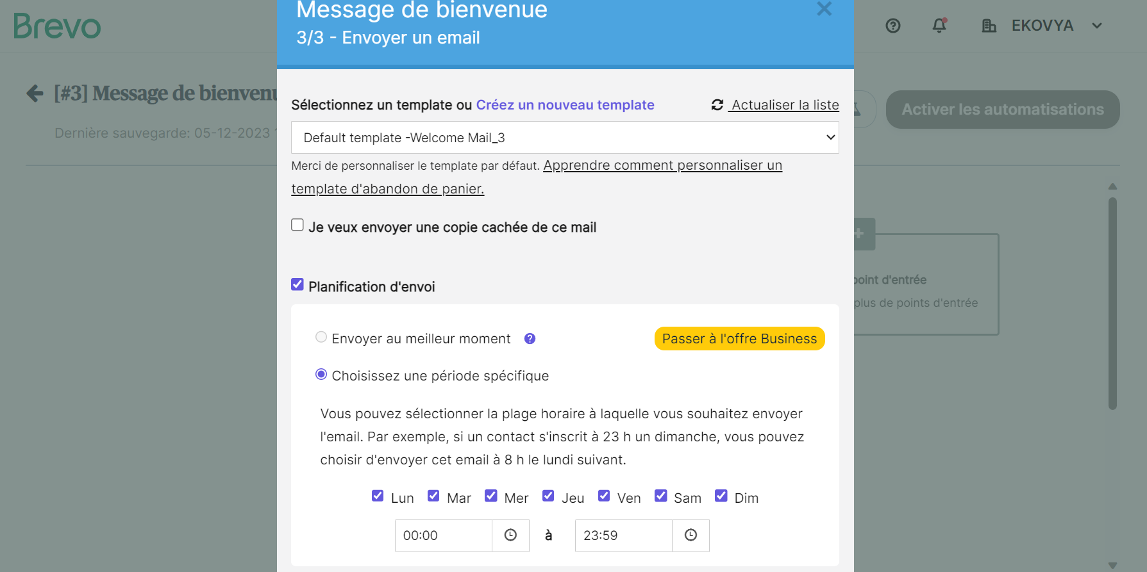

* Click on “Finish”

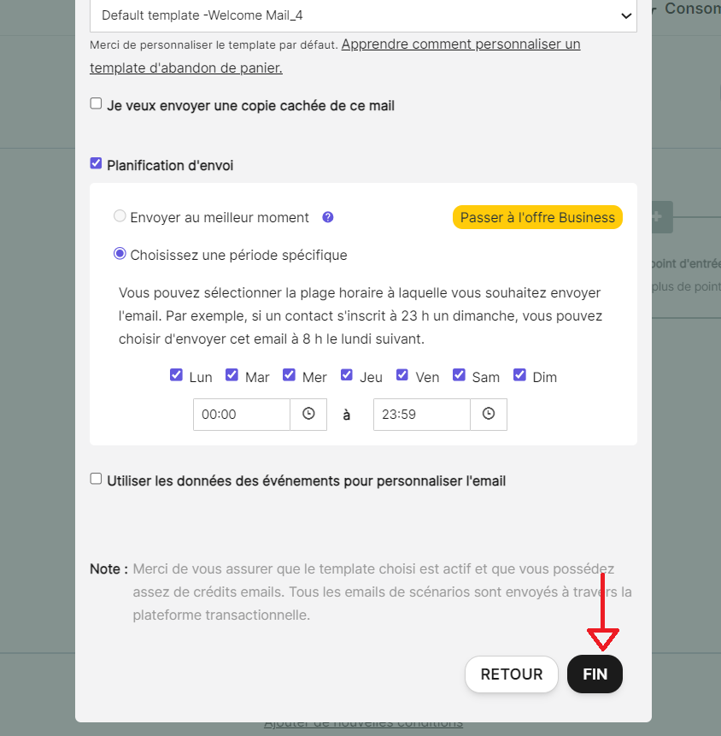

* Check the flow
* Click on “Activate the flow”

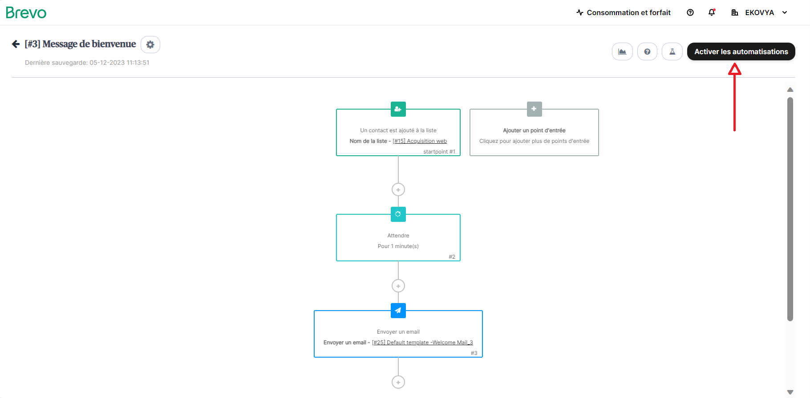

## 7.2 Inscription to the Newsletter

* From the home page: select “Automations”
* Click on “Customized flow”

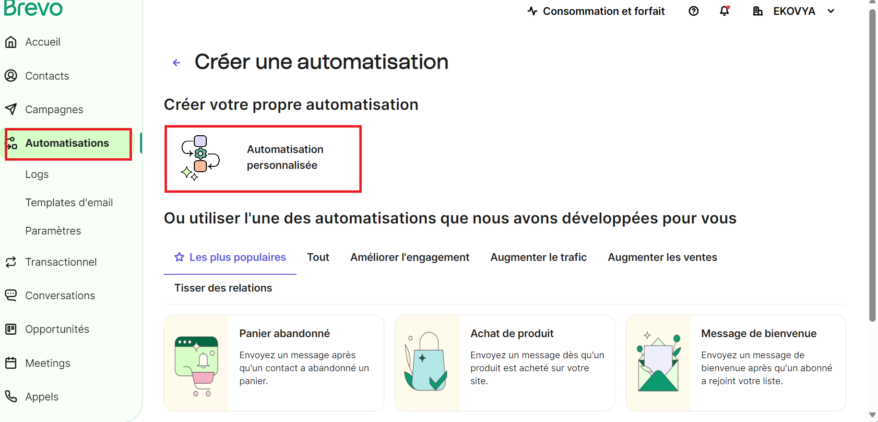

* Name the flow and a enter a description
* Click on “Create a flow”

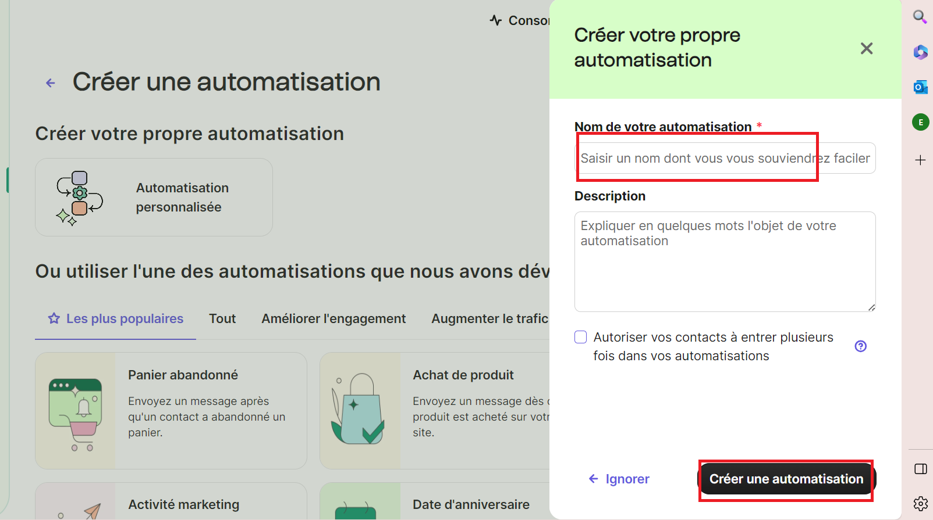

* Click on “+”

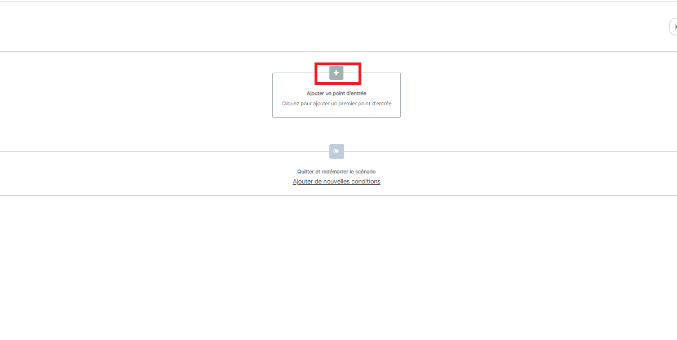

* Select: when a contact submit a form

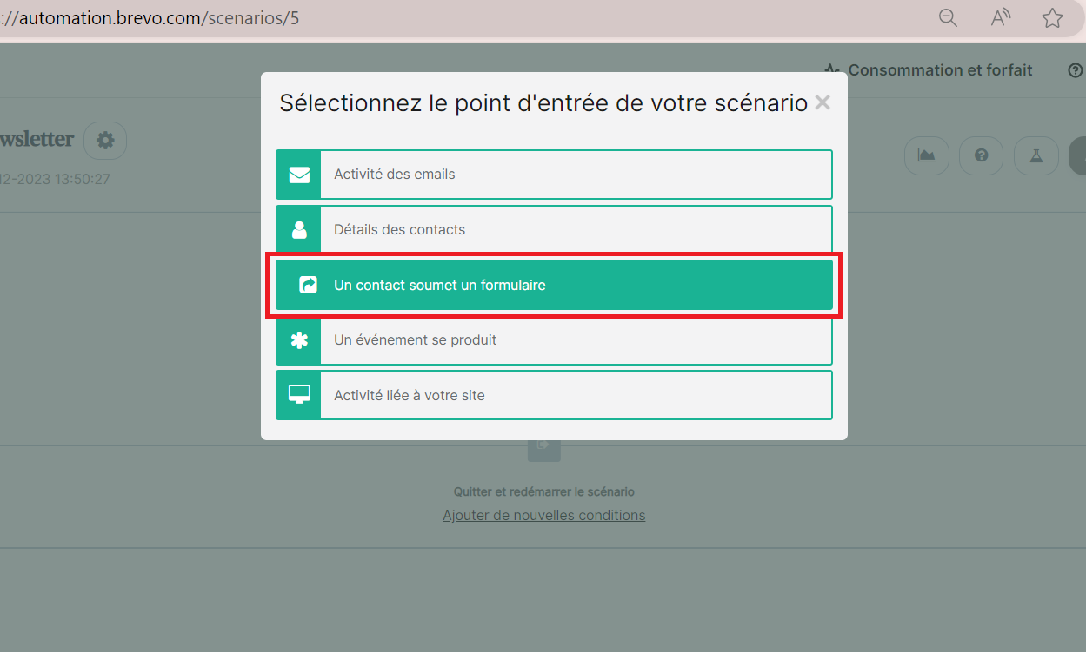

* Select an email template
* Click on “Ok”

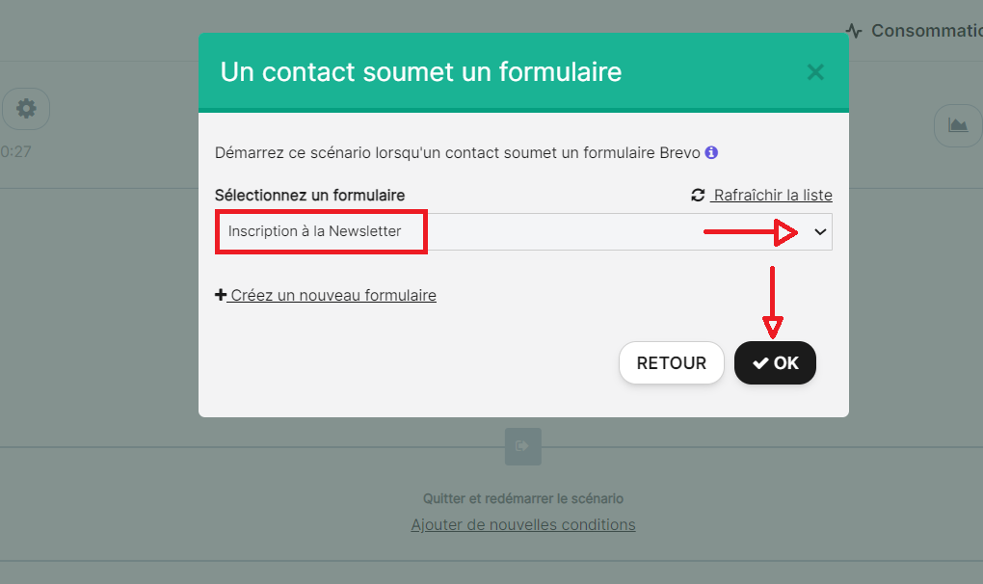

* Click on “+”

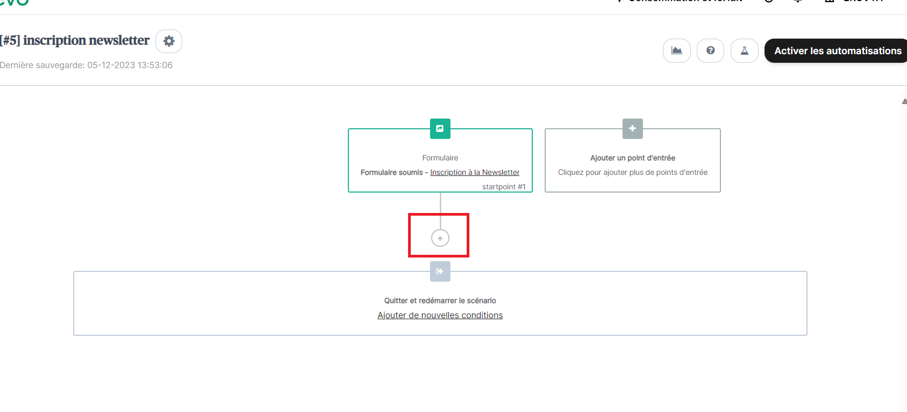

Click on “Send email”

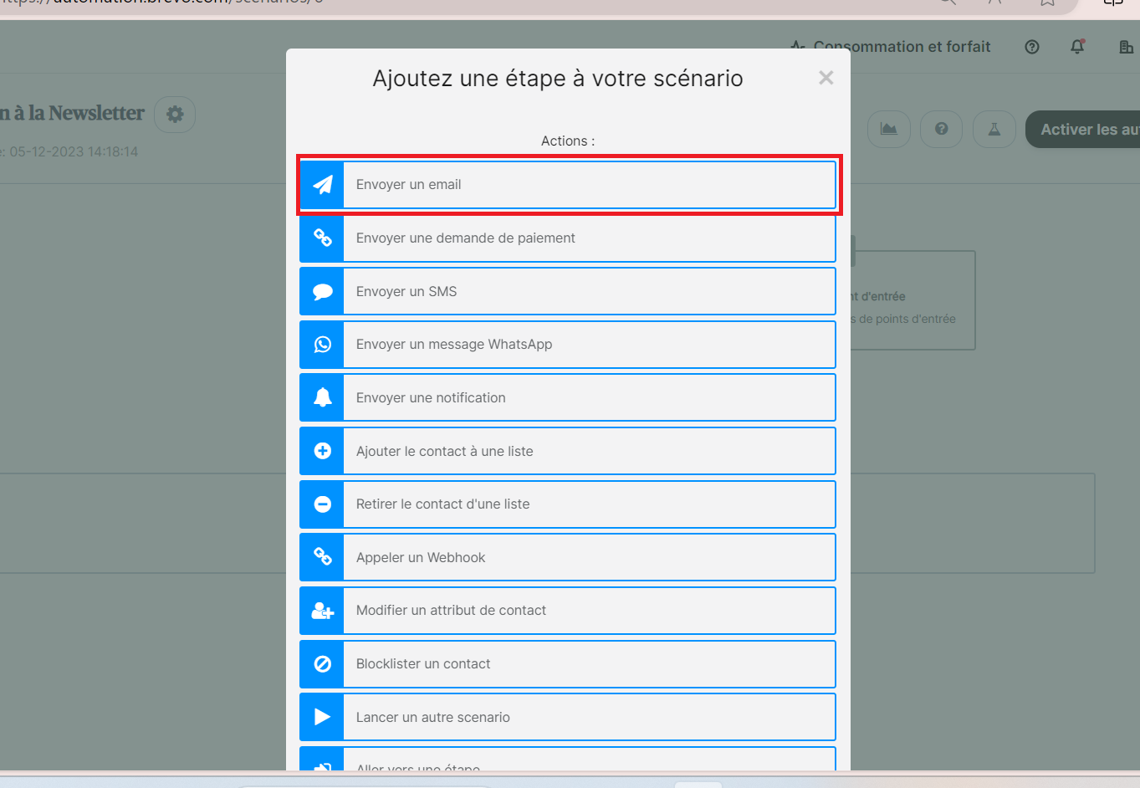

* Choose an email template to send
* Click on “Ok”

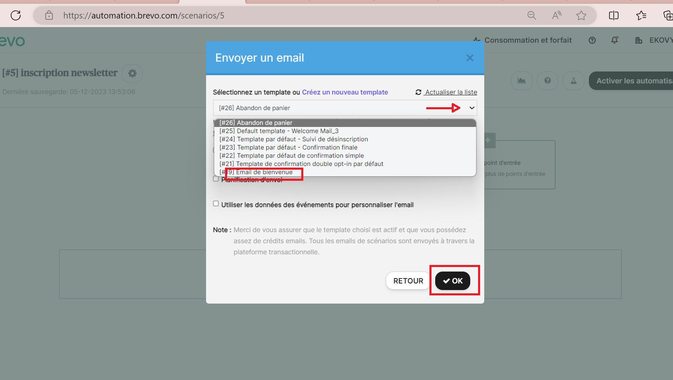

* Check the first box to send an email copy to the manager

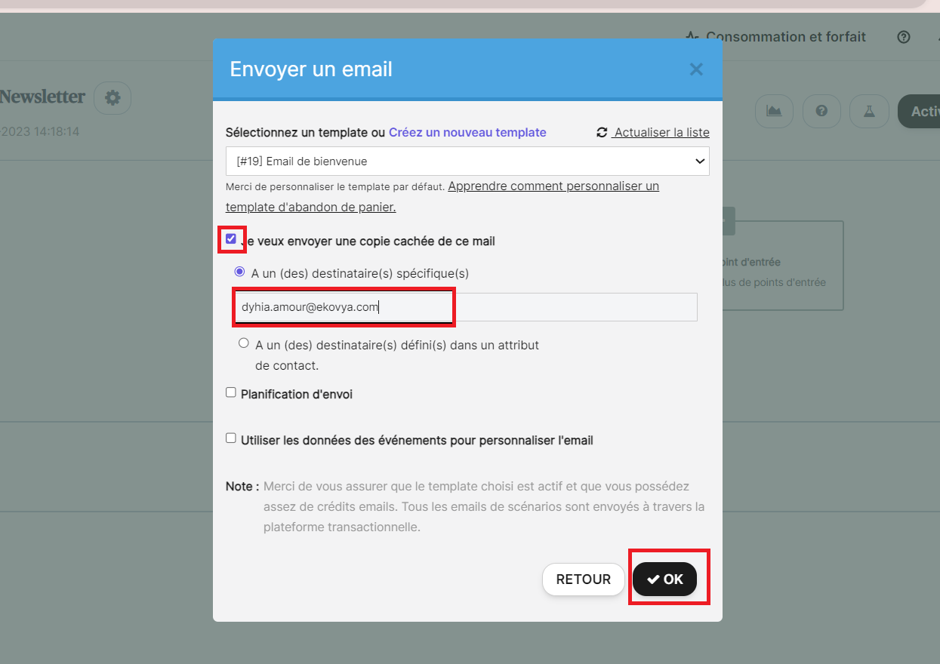

* Click on “+”

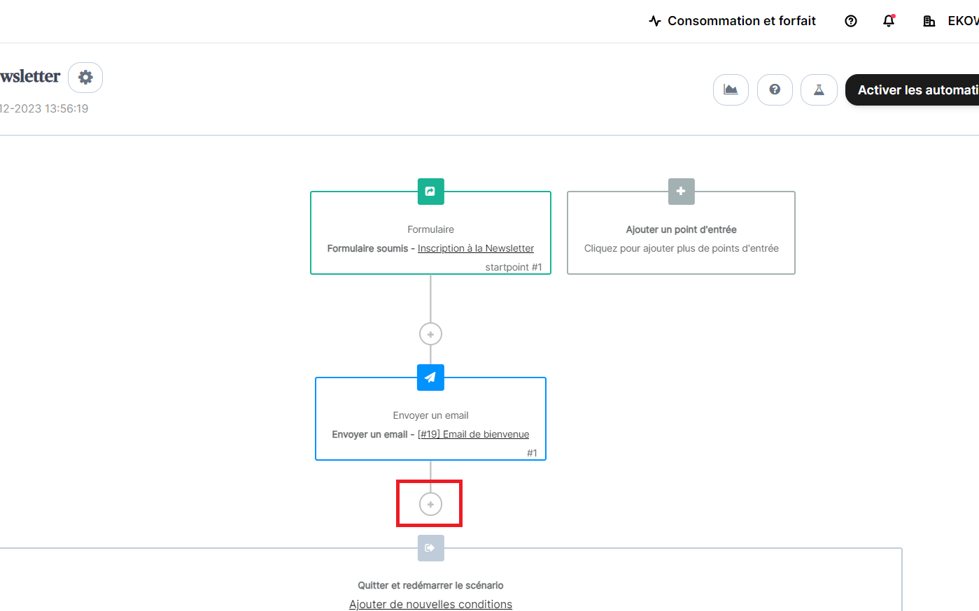

* Add a condition if/else

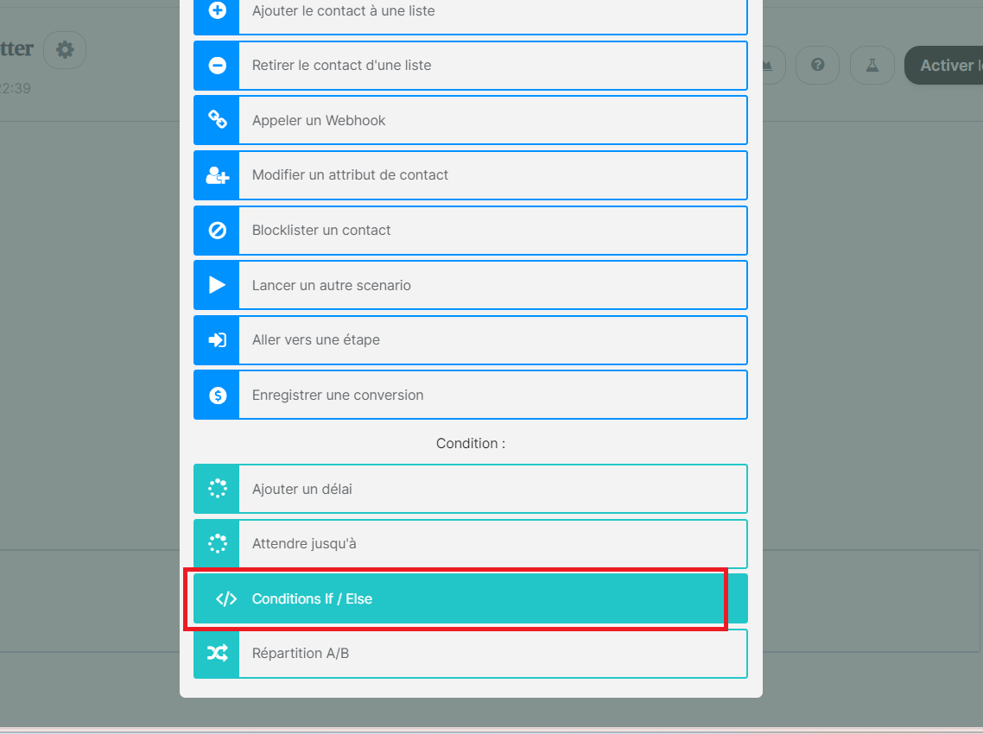

* Select: Transactional email activity

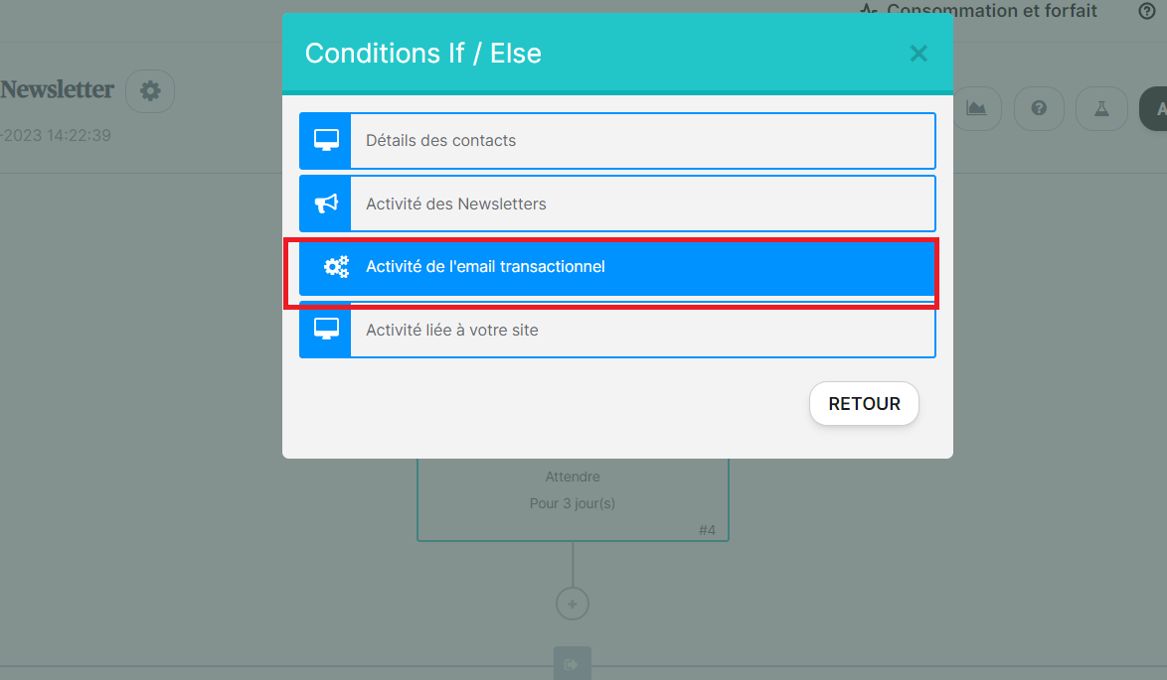

* Check the second box to customize the process

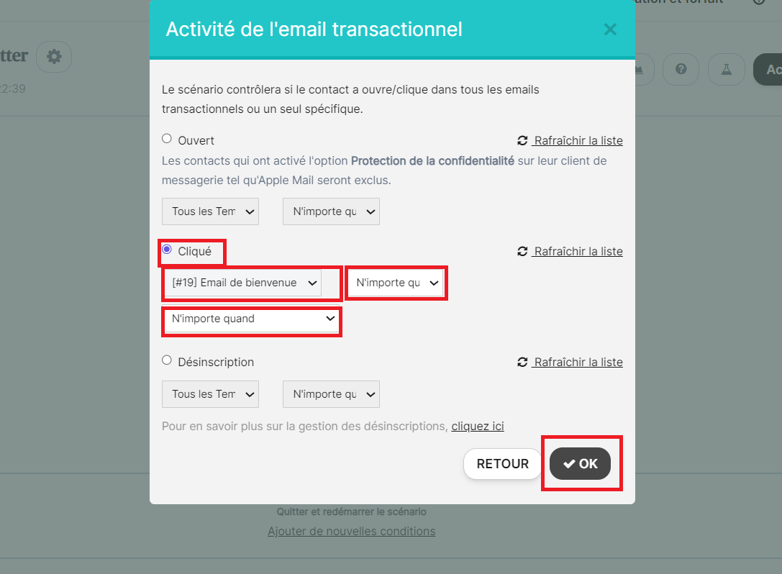

* Click on “Activate the flow”

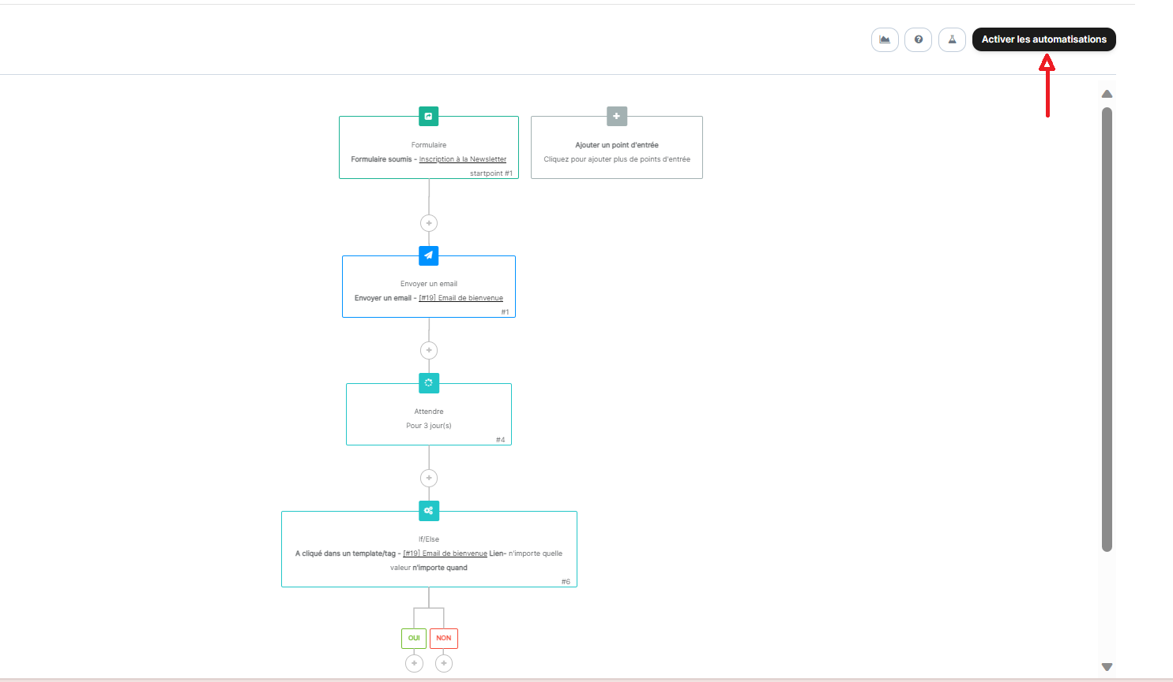

We can create email templates to send whether the contact open or not the mail